What does my support network look like?



Who are my most trusted people and who else supports me?

The right direction logo - Working together on positive behaviour support (PBS).


## Instructions for the behaviour support practitioner

There are different ways of thinking about [someone with a behaviour support plan’s support network](https://therightdirectionpbs.com/resources/support-networks), including how they see themselves in relation to it and also who might be in [their Circle of Support](https://therightdirectionpbs.com/downloads/support%20networks/working_effectively_within_support_networks_and_with_circles_of_support.docx). This is useful, because everyone’s situation, needs and wants differ.

Who is closest to (or most important to) a person in their support network might vary from day to day (or even from hour to hour) depending on their context and needs in any situation. Alternatively, a person’s support network might be relatively stable and have little change.

Many people have relationships across various groups, and as they meet new people, those relationships may move into different groups over time.

### Participants’ relationship to their support networks

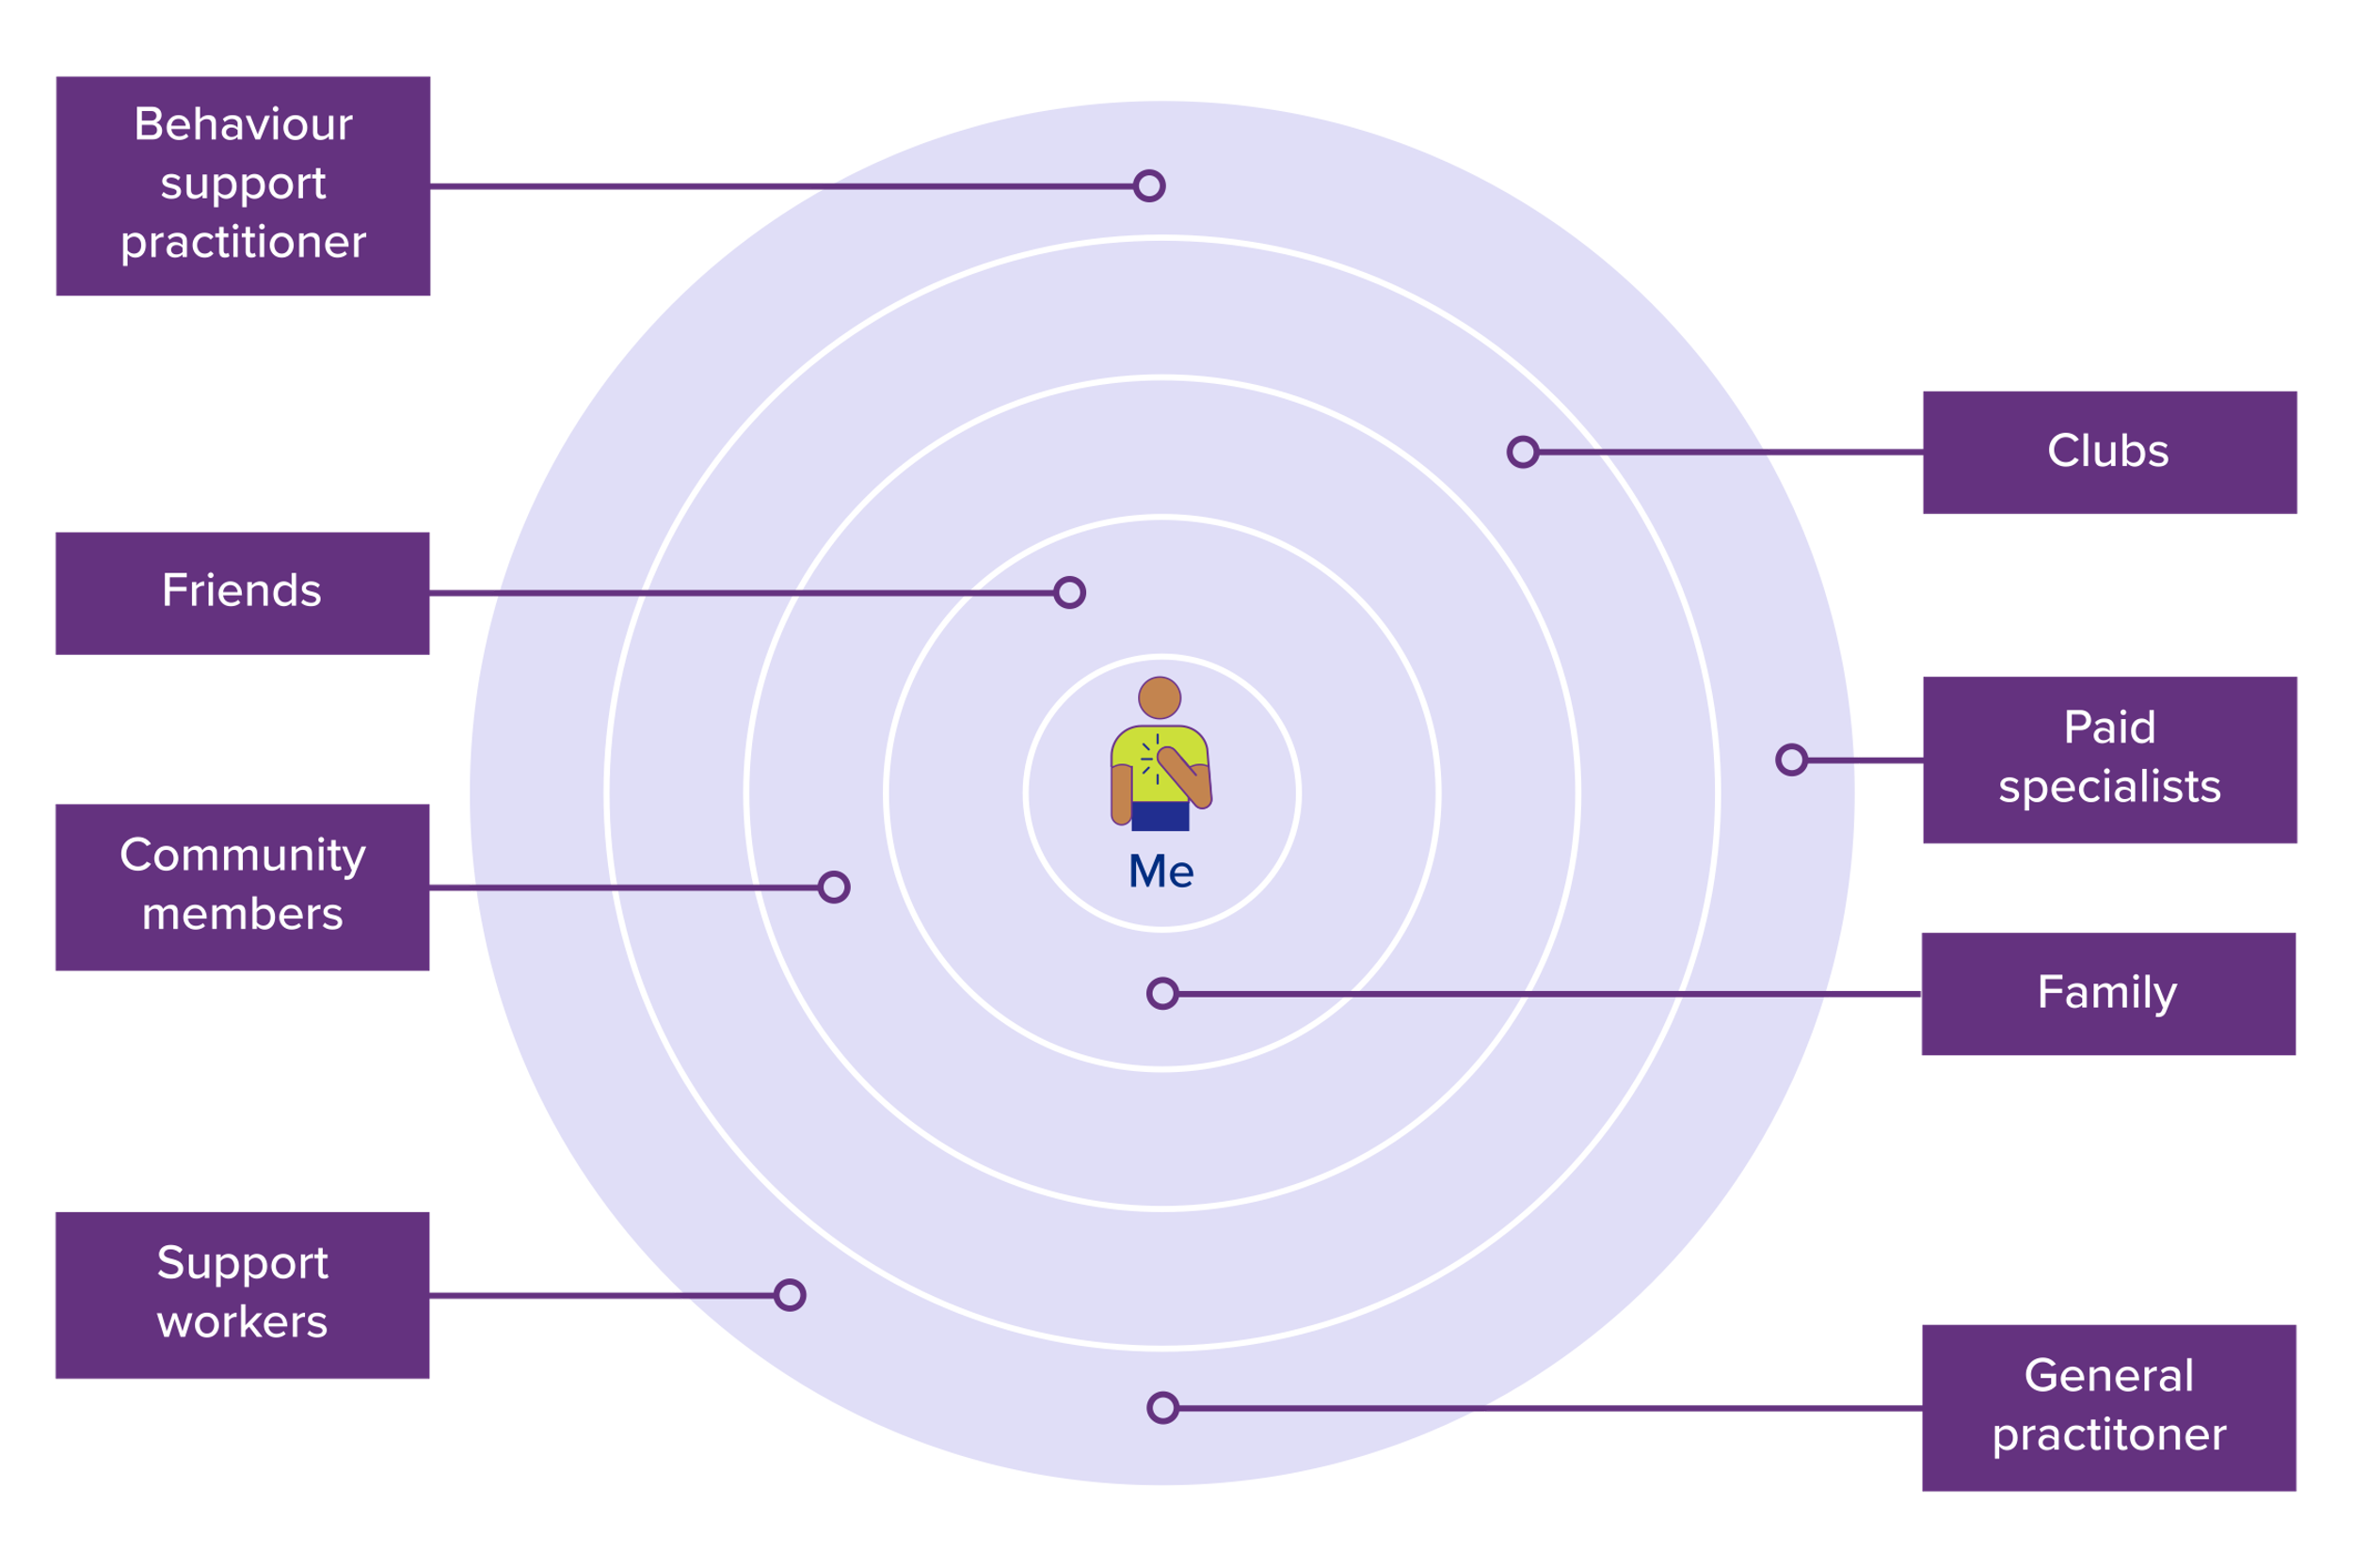Sometimes the person with disability might consider themselves at the centre of a circle, with their support network uniting around them to provide support.

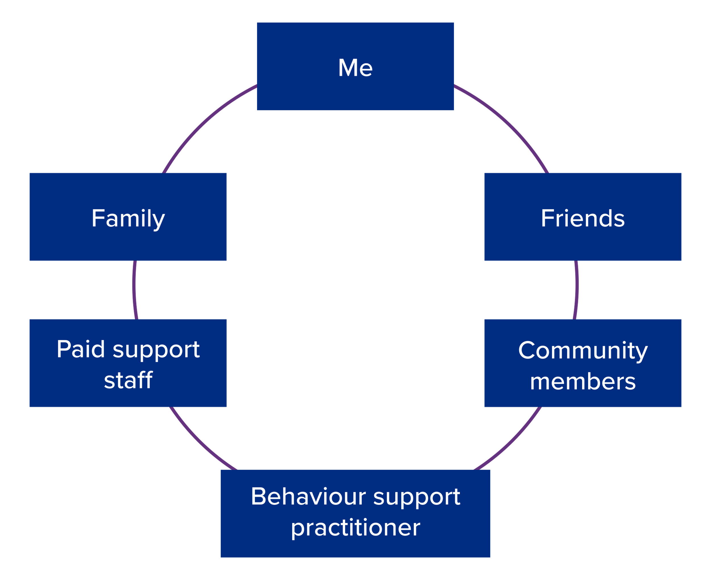Sometimes the person with disability prefers a support network that shows them as an equal, where things happen with them, not around them, such as the model below.

As a behaviour support practitioner, engage the person with disability to understand how they view themselves and how they see their support network and their place in it.

A valuable tool for identifying the most trusted people in the participant’s support network is [the Hand of Trust](https://therightdirectionpbs.com/resources/your-support-network#hand-of-trust). This can also be helpful for people who may not have a clear understanding of who is in their support network and what it looks like.

As a behaviour support practitioner, you may also find that for some people with disability there are missing relationships in some groups. For example, some people may have close family, but lack friends or community.

Some people might have lots of paid support people and specialists, but fewer people in other groups.

A part of your behaviour support planning process you might include strategies for developing people’s support networks. By identifying who is in a person’s broader network, you could also work together to help plan ways to develop new relationships. For example, someone from a club could eventually become a friend.

Below are templates you can use with participants to identify people in their support networks and explain who could fit where in the diagrams.

# For the participant:

## Who is (or could be) in your support network?

**1. Your closest people**

This group includes the people who are closest to you, like family members, a boyfriend, girlfriend or partner, or very close friends. These are the people whose absence would have a big impact on your life.

**2. Other people you like to spend time with**

This group includes people who you like to spend time with and people who like to spend time with you. This could be friends or relatives who you might go out to dinner or watch a movie with. They are not your closest people, but they are important to you.

**3. Your community supports**

This group includes unpaid people and groups who you see regularly, maybe in the local community like in clubs or activities. These relationships may eventually grow closer and could be where new relationships start to form.

**4. Paid community supports**

This group includes people who are paid members of the community, such as florist, hairdressers, newsagents and staff at the local supermarket. These are professional relationships, but often also friendly.

**5. Your paid support**

This group includes people who are paid to support you, such as doctors, teachers, therapists, support workers or other NDIS service providers. These are professional relationships rather than personal ones, and they’re usually focused on providing specific services.

## My support network

Use names, photos or drawings to say who is in your support network and how close they are to you.

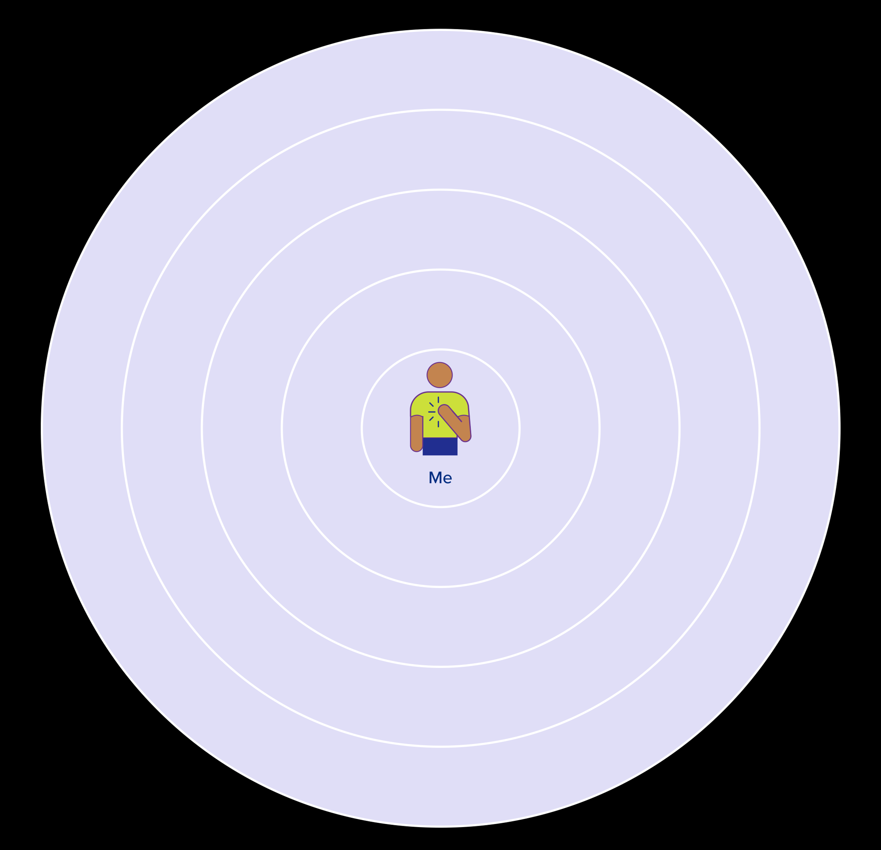

## My support network

Use names, photos or drawings to say who is in your support network and how close they are to you.



The right direction logo - Working together on positive behaviour support (PBS).
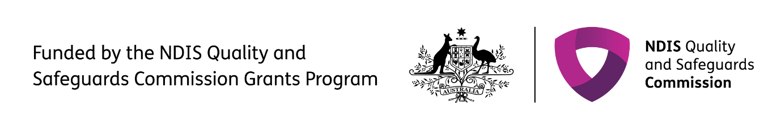

Published in 2025

**therightdirectionpbs.com**