Using Key Word Sign (KWS) in behaviour support planning



## An added strategy for successful communication and engagement

The right direction logo - Working together on positive behaviour support (PBS).


# Using Key Word Sign in behaviour support planning

## What is Key Word Sign (KWS)?

Key Word Sign is sometimes called KWS. It is a tool or strategy that can be used to support children and adults who communicate differently.

Sometimes, people may already know how to use Key Word Sign to communicate. Or, together, you may choose to try Key Word Sign.

Key Word Sign allows people to add a physical sign for key words or information to help support spoken conversation. Key Word Sign is a form of unaided augmentative and alternative communication (AAC).

## How can Key Word Sign help with behaviour support?

Key Word Sign can be used to communicate information (sometimes called an ‘expressive’ communication strategy) and to support someone in understanding information (sometimes called a ‘receptive’ communication strategy).

Key Word Sign can help by:

1. reducing frustration by providing an effective way to communicate your message
2. helping people understand spoken words and
3. encouraging eye contact and attention between people in a conversation.

### Reducing frustration

Imagine how you would feel if you were trying to communicate and no one could understand you.

You might become frustrated and, over time, you might even give up.

This could mean that you withdraw from social interaction or only communicate about your basic needs.

If there was pressure for you to communicate information, eventually you may resort to behaving in a certain way to demonstrate the frustration you are feeling.

Key Word Sign can give some people a way of communicating how they feel or what they think without the need to point to pictures, photos or rely on speech. Being able to communicate effectively reduces frustration and hopefully facilitates conversations about people’s rights, needs, choices and goals, all of which are essential during the behaviour support planning process.

### Helping people understand spoken words

Speech is often delivered quickly, with speakers naturally using many words and sometimes complex ideas.

For this to be effective in engagement, it relies on a person who can process this information at speed and without any concrete or static visual cues. It can therefore be difficult for people who need these supports to understand communication using spoken words.

Key Word Sign adds visual cues, slows the speed of spoken words and encourages people to speak in shorter phrases of sentences, often naturally also using words that are easier to understand. This provides more time for others to process and understand information and is fundamental to successful engagement in the behaviour support planning process.

### Encouraging eye contact and attention

For many people, eye contact is an important part of engagement during conversation.

When we sign as we speak, we become more visually interesting to look at. Inviting this eye contact from the person we are communicating with can help them stay focused on the conversation.

Equally, some people may prefer not to make eye contact or find eye contact difficult to maintain. Using Key Word Sign provides communication in a way that doesn’t require the person to look at the communication partner’s face.

## How you can support someone using Key Word Sign

* Learn some common signs that can be used across different conversations (e.g., hello, goodbye, yes, no, help, more, stop, etc.).
* Learn signs that are specific to the topic you are talking about. e.g., behaviour, emotions, health.
* Learn ‘idiosyncratic’ signs that might be used by the person you are working with (this means signs they have invented that are specific to them).

Not all people will have the cognitive ability or physical ability to effectively use signs to communicate information, but many people will benefit from their communication partners using Key Word Sign when communicating with them to enhance their understanding.

If a person's communication profile is not available or not complete, it is important to find out more about the person’s preferred ways of and needs when communicating, perhaps through the person’s support networks – both person and professional.

This can help you understand whether Key Word Sign is a useful tool and – if it is – whether it works best for the person as an expressive or receptive communication strategy.

The right direction logo - Working together on positive behaviour support (PBS).


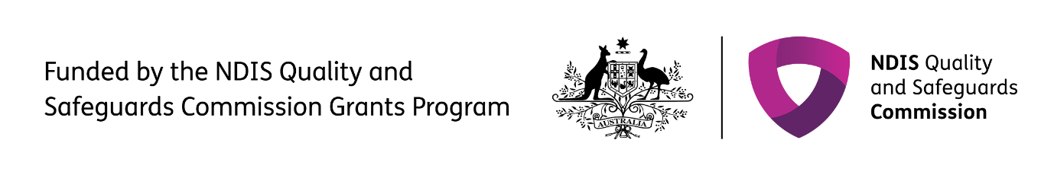

Published in 2025

**therightdirectionpbs.com**