Using discussion mats in behaviour support planning



## Supporting 2-way communication for effective engagement

The right direction logo - Working together on positive behaviour support (PBS).


# Engaging effectively using discussion mats

We all have opinions about what we like or don’t like and what we want or do not want. Based on our opinions, feelings and preferences, this is how we make choices.

People can have preferences about:

* who they want in their support networks,
* where they want to live,
* what clothes they like to wear,
* what they like and don’t like doing (eg: at a day service), and
* sensory input.

To make a choice we have to know our options, balance those options in our mind and make a decision. This is very important when it comes to developing and implementing a behaviour support plan.

People need to know their options about their behaviour support and also understand how they will be supported to make those decisions.

This could include making decisions about:

1. their daily routine,
2. activities they get to do,
3. places they get to go, and
4. people who they spend time with (including who is going to support them).

Importantly, the person’s decisions about their behaviour support plan should be respected, even if the decision is not what a family member, support worker or behaviour support practitioner might have chosen (see [working with support networks](https://therightdirectionpbs.com/resources/working-with-support-networks) and [engaging others in change](https://therightdirectionpbs.com/resources/engaging-others-in-change)).

Sometimes, the decision this might involve taking risks. It is important the person understands any risks as part of the decision-making process.

It is also important to remember that [people have rights](https://therightdirectionpbs.com/resources/communication-rights#peoples-commnication-rights-list) that behaviour support practitioners need to uphold and communicate, such as making choices.

For many people with disability, decisions have always been made for them by other people. As such, being able to express those choices are skills that not everyone has had an opportunity to learn. It is possible that is could even be contributing to the person’s behaviours of concern.

[Learning about their rights](https://therightdirectionpbs.com/resources/communication-rights), having an opportunity to express their opinions, and building the skills to make good choices could be an important part of a person’s behaviour support plan.

A discussion mat is [one tool of many](https://therightdirectionpbs.com/resources/different-communication-techniques) that could be used by a behaviour support practitioner when talking with a person with disability about their behaviour support plan and introducing the options.

### What is a discussion mat?

A discussion mat is a visual communication tool that supports people with different communication needs or complex communication needs to express their feelings and views.

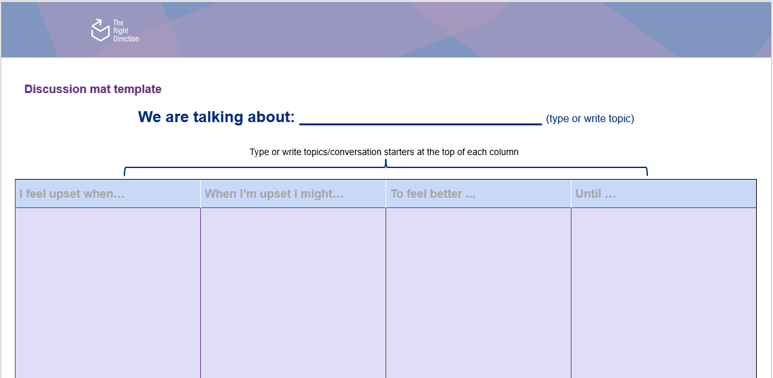You can find a [discussion mat template](https://therightdirectionpbs.com/downloads/using-discussion-mats/different_communication_techniques_discussion_mat_and_picture_cards_template_A3.docx) (shown below) as part of [The Right Direction resources](https://therightdirectionpbs.com) and also find some examples to use when [talking about behaviours of concern](https://therightdirectionpbs.com/resources/behaviours-of-concern) and [restrictive practices](https://therightdirectionpbs.com/resources/restrictive-practices) if this technique is useful for you in engaging your participants in the behaviour support process.

### How to set up the discussion mat template

1. Choose a topic for your discussion and write it in the space on the board.
2. 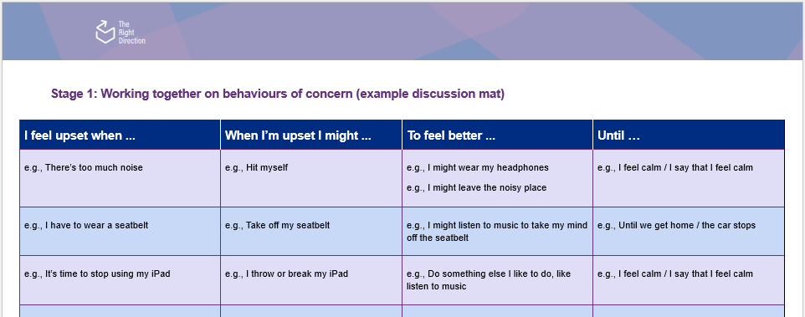Use each column as a part of the discussion, moving the decision-making process forward. Write simple discussion starters at the top of each column, for example:

See more information in [this example mat for talking about behaviours of concern](https://therightdirectionpbs.com/downloads/adapting-communication/behaviours-of-concern-example-discussion-mat-A3.docx).

1. Use each column heading to start or continue the discussion. You can each respond using picture cards, drawings or words in the column, to note key information and show thoughts and feelings relating to the topic.
2. Make sure you give the participant the options one at a time and ask them to think about each one. Give them time the time they need and make sure they don’t feel rushed.

### Why do discussion mats work?

There are several reasons why discussion mats work. They improve the engagement between participant and practitioner because they support comprehension by providing an additional communication method that can either support or replace verbal words, which strengthens and improves the quality of information.

This can be used to help communication and further conversation, by:

* reducing memory demands by breaking information down into small, manageable units,
* allowing the participant more control in the engagement,
* enabling the participant to process information and respond in their own time, and
* providing a structured framework for open questions.

These features can also help to reduce anxiety during the conversation and support the participant to express how they really feel.

You should start by using the discussion mat on small decisions so the person can get used to them and you can establish mutual trust and engagement using the mat, before using them on more important decisions.

As a behaviour support practitioner, you can seek optional formal training through [Talking Mats Australia](https://talkingmatsaustralia.com.au/).

Participants don’t require any training to use discussion mats or Talking Mats, but practitioners may find that introducing the discussion mat several times is helpful.



**therightdirectionpbs.com**

The right direction logo - Working together on positive behaviour support (PBS).


Published in 2025