Different communication techniques



## Picture cards template (A3)

## 

The right direction logo - Working together on positive behaviour support (PBS).


## How to use these cards – instructions for practitioners

Before going to see your behaviour support participant, this template may be a useful tool to create custom cards to help with a discussion or decision.

Behaviour support practitioners can insert pictures or photos that are relevant to the participant in these blank squares and give the card a label using the text box. You can also use the Word image and icon library, or draw/write in the boxes with the participant on a blank printed set of cards.

Before you print, delete the text box if you don’t use it, because it will show on the printed version.

Print these picture cards on A3 paper and cut them out to use by themselves or with [a customised discussion mat](https://therightdirectionpbs.com/downloads/using-discussion-mats/different_communication_techniques_discussion_mat_and_picture_cards_template_A3.docx).

If you would prefer, you can also access picture cards of different sizes on The [Right Direction website](https://therightdirectionpbs.com/), including:

* an [A4 picture card template](https://therightdirectionpbs.com/downloads/using-discussion-mats/different_communication_techniques_picture_cards_template_A4.docx);
* an [A4 template for making larger picture cards](https://therightdirectionpbs.com/downloads/using-discussion-mats/different_communication_techniques_large_picture_cards_template_A4.docx);
* [communicating about behaviours of concern](https://therightdirectionpbs.com/resources/behaviours-of-concern);
* [communicating about restrictive practices](https://therightdirectionpbs.com/resources/restrictive-practices); and
* [working effectively within support networks](https://therightdirectionpbs.com/resources/working-with-support-networks).

|  |  |  |  |
| --- | --- | --- | --- |
| Type words here (or delete) |  |  |  |
|  |  |  |  |
|  |  |  |  |
|  |  |  |  |

**Picture cards template**



**therightdirectionpbs.com**

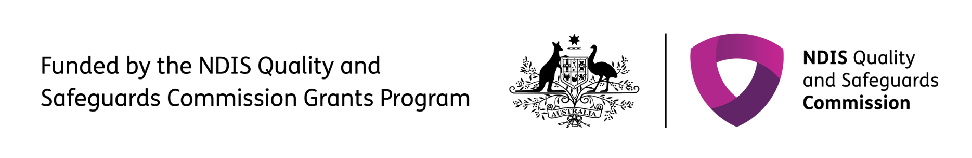The right direction logo - Working together on positive behaviour support (PBS).


Published in 2025