Using different communication techniques



## Discussion mat and picture card templates

The right direction logo - Working together on positive behaviour support (PBS).


## How to use these templates – instructions for behaviour support practitioners

|  |  |
| --- | --- |
| **Discussion mat template**  This is a flexible discussion mat template for behaviour support practitioners to use with participants.  You can customise this template to suit the discussion or decision you plan to have with a participant as part of their behaviour support planning process.  Several picture cards are provided on The Right Direction website, or you can also make your own.  Use this mat as the start of your discussion, prompting ideas and options that work for each individual.  Print templates on A3 or A4, or create your own using other materials.  You may also wish to watch The Right Direction video on [using discussion mats](https://therightdirectionpbs.com/resources/using-discussion-mats#video) or refer to the [information about using discussion mats](https://therightdirectionpbs.com/resources/using-discussion-mats) to get you started. | **Picture cards template**  Before going to see your behaviour support participant, this template may be a useful tool to create custom cards to help with a discussion.  Behaviour support practitioners can insert pictures or photos that are relevant to the participant in these blank squares and give the card a label using the text box. You can also use the Word image and icon library, or draw/write in the boxes with the participant on a blank printed set of cards.  Before you print, delete the text box if you don’t use it, because it will show on the printed version.  Print these picture cards on A3 paper (or scale to A4) and cut them out to use by themselves or with the included discussion mat template. They are sized to fit with the discussion-mat template in this document.  If you would prefer, you can also access picture cards of different sizes on The [Right Direction website](https://therightdirectionpbs.com/), including: an [A4 picture card template](https://therightdirectionpbs.com/downloads/using-discussion-mats/different_communication_techniques_picture_cards_template_A4.docx); an [A4 template for making larger picture cards](https://therightdirectionpbs.com/downloads/using-discussion-mats/different_communication_techniques_large_picture_cards_template_A4.docx); [communicating about behaviours of concern](https://therightdirectionpbs.com/resources/behaviours-of-concern); [communicating about restrictive practices](https://therightdirectionpbs.com/resources/restrictive-practices); and [working effectively within support networks](https://therightdirectionpbs.com/resources/working-with-support-networks). |

### Discussion mat template

## We are talking about: ____________________________ (type or write topic)

Type or write topics/conversation starters at the top of each column

|  |  |  |  |
| --- | --- | --- | --- |
| I feel upset when… | When I’m upset I might… | To feel better ... | Until … |
|  |  |  |  |

### Picture cards template

|  |  |  |  |  |  |  |
| --- | --- | --- | --- | --- | --- | --- |
| Insert text here  Insert text here  Insert text here | Insert text here  Insert text here  Insert text here | Insert text here  Insert text here  Insert text here | Insert text here  Insert text here  Insert text here | Insert text here  Insert text here  Insert text here | Insert text here  Insert text here  Insert text here | Insert text here |
| Insert text here  Insert text here  Insert text here | Insert text here  Insert text here  Insert text here | Insert text here  Insert text here  Insert text here | Insert text here  Insert text here  Insert text here | Insert text here  Insert text here  Insert text here | Insert text here  Insert text here  Insert text here | Insert text here |
| Insert text here  Insert text here  Insert text here | Insert text here  Insert text here  Insert text here | Insert text here  Insert text here  Insert text here | Insert text here  Insert text here  Insert text here | Insert text here  Insert text here  Insert text here | Insert text here  Insert text here  Insert text here | Insert text here |
| Insert text here  Insert text here  Insert text here | Insert text here  Insert text here  Insert text here | Insert text here  Insert text here  Insert text here | Insert text here  Insert text here  Insert text here | Insert text here  Insert text here  Insert text here | Insert text here  Insert text here  Insert text here | Insert text here |

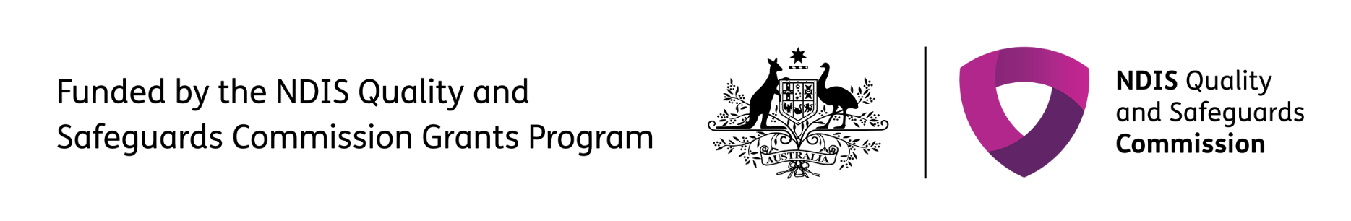The right direction logo - Working together on positive behaviour support (PBS).


Published in 2025

**therightdirectionpbs.com**