Toward my goals



## Visual rating scale (editable)

The right direction logo - Working together on positive behaviour support (PBS).


# Goal rating scale

## Do you agree?



# I do not agree

# I do not know

# I agree

# Goal rating scale

## Do you agree?

# Goal rating scale

# I do not agree

# I do not know

# I agree

## Do you agree?

# Goal rating scale

# I do not agree

# I do not know

# I agree

## Do you agree?



Insert your own image here

Insert your own image here

Insert your own image here

# I do not agree

# I do not know

# I agree



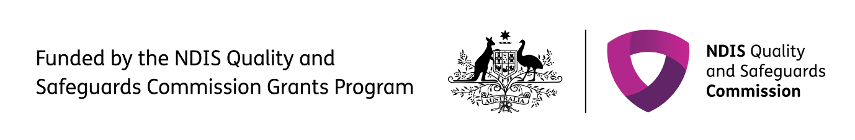The right direction logo - Working together on positive behaviour support (PBS).


Published in 2025

**therightdirectionpbs.com**