Toward your goals:



Planning from   
here to there

## Working together on achieving participants’ goals

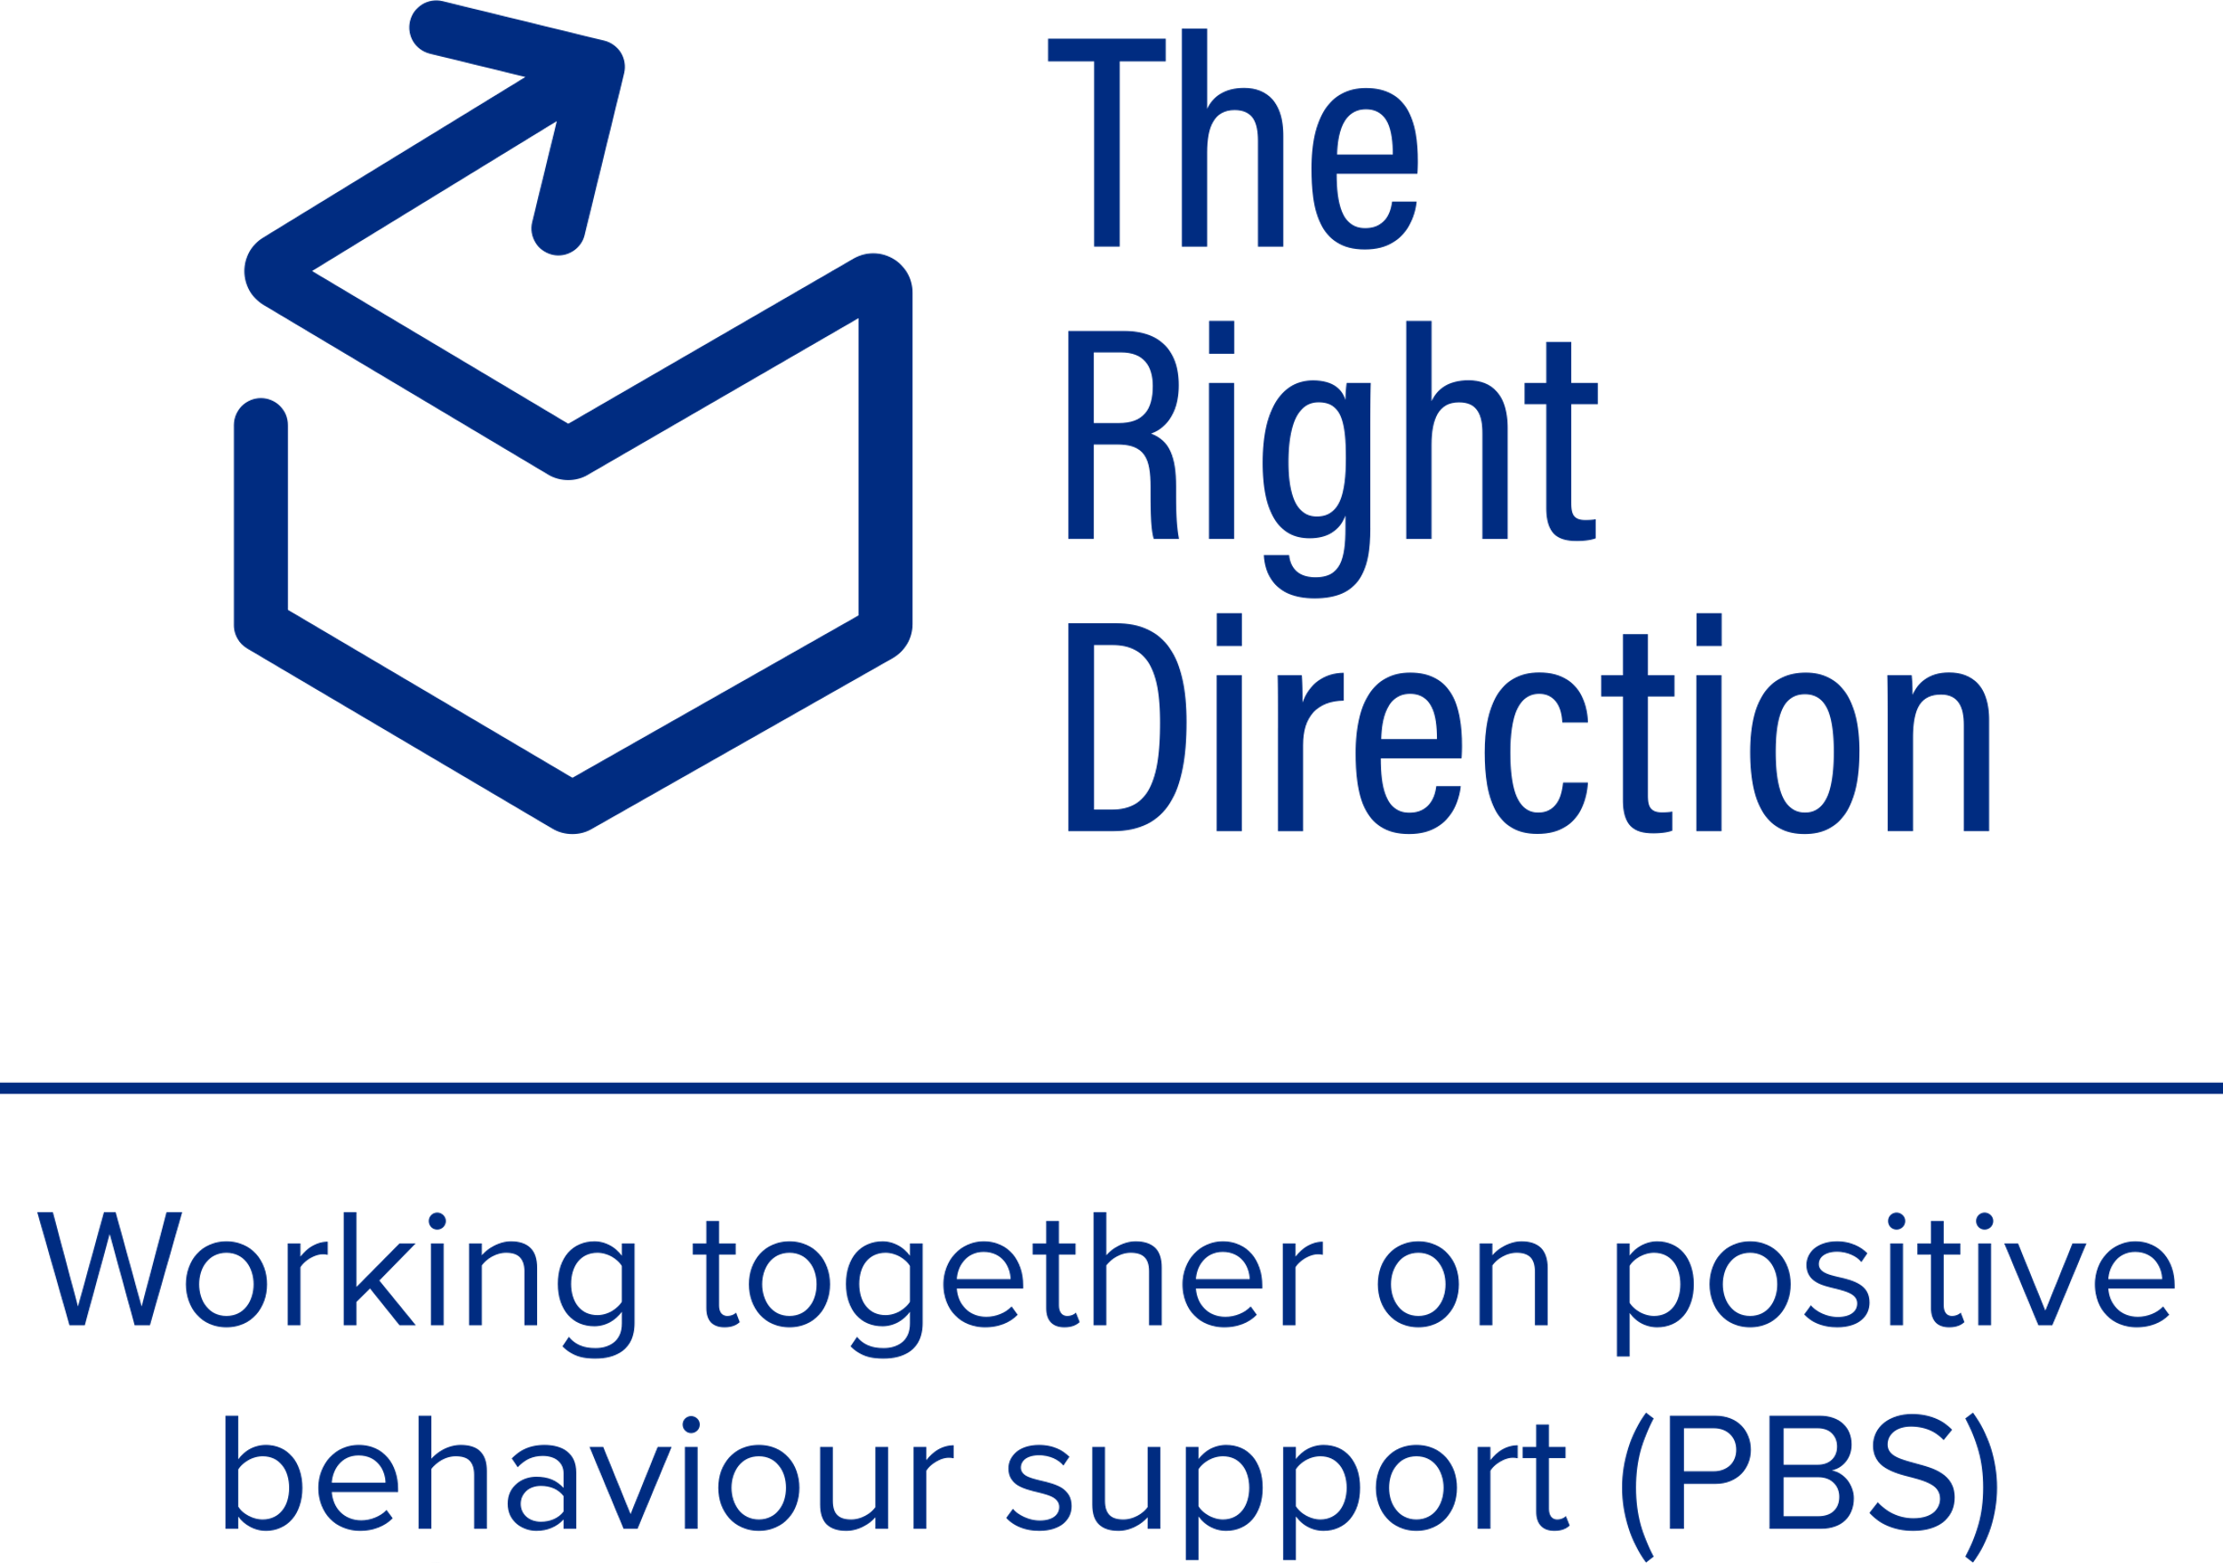

## Instructions for behaviour support practitioners

### Working together to get from here to there

This guide helps behaviour support practitioners work with their behaviour support participants on the plan for moving from the participant’s current situation toward achieving their goals and improving safety and wellbeing.

It focuses on how to have the discussion about connecting the behaviour support plan meaningfully with the goals it aims to achieve – a critical part of engagement for both the participant and their support network.

You will now have worked with the participant to understand what their goals look like, both in life and for their behaviour support plan. The Right Direction workbook [my good life goals](https://therightdirectionpbs.com/resources/my-good-life-goals) helps you work together to plan where participants **want** to be and the workbook [my behaviour support goals](https://therightdirectionpbs.com/resources/behaviour-support-goals) helps you work together to plan realistic goals that contribute to moving closer to those life goals.

It is now time to work together to agree on the steps and strategies to achieve these goals.

Throughout this important step, refer back to the **benefits** of making these changes in their lives and how these changes move them toward their good life goals. This is a powerful motivational tool and can help you engage your participant in the behaviour changes because they can understand that these goals are positive things that help them achieve something important to them.

Behaviour change and a process for successfully engaging people in it is discussed further in [Preparing for and conducting inclusive behaviour support planning](https://therightdirectionpbs.com/resources/preparing-and-conducting-behaviour-support-planning) and [engaging support networks in change](https://therightdirectionpbs.com/resources/support-networks-and-change).

### Toward your goals rating scale

To help you speak with your participant about their proposed goals and improve communication between you, you may wish to use a rating scale.

You can print a [pre-designed rating scale](https://therightdirectionpbs.com/downloads/toward-your-goals/visual_rating_scale.pdf) or [download an editable rating scale](https://therightdirectionpbs.com/downloads/toward-your-goals/visual_rating_scale_template.docx) that includes different options and also the chance to customise the scale according to your participant’s needs and preferences.

Using a visual rating scale provides an additional visual resource to support communication and engagement for you to use together.

[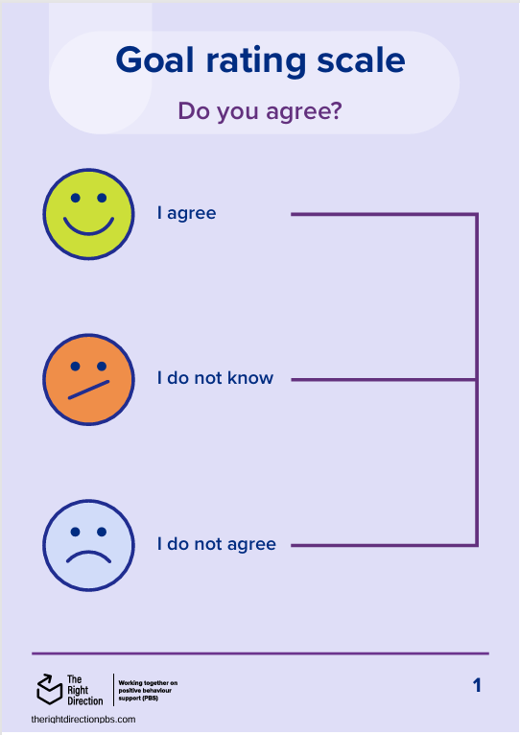](https://therightdirectionpbs.com/downloads/toward-your-goals/visual_rating_scale.pdf)

## A conversation plan

Some simple steps to guide you through the conversation of moving from ‘here’ to ‘there’ could include:

1. **Introduce the agreed goal(s)** [for the behaviour support plan](https://therightdirectionpbs.com/resources/behaviour-support-goals) and proposed/ possible strategies for achieving each goal.
2. **Talk about who** will – or could be (if alternatives are practical) – using these strategies and [who needs to be involved](https://therightdirectionpbs.com/resources/sharing-and-staying-connected).
3. **Confirm the participant’s consent** for sharing any information with the person/people proposed to be involved (and be clear about what information you plan to share).
4. **Agree on the strategies**, timeframes and people involved.
5. **Communicate about reviewing the plan**, including when you will begin working together on [reviewing the goal(s)](https://therightdirectionpbs.com/resources/revisiting-the-behaviour-support-plan) and your role in leading this process.

## Using a visual rating scale

Make sure you have a copy of [a visual rating scale available](https://therightdirectionpbs.com/downloads/toward-your-goals/visual_rating_scale_template.docx), either digitally (for example on an iPad) or a paper-based version.

[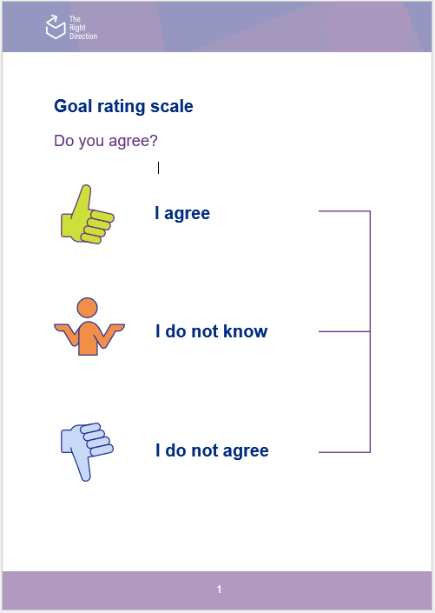](https://therightdirectionpbs.com/downloads/toward-your-goals/visual_rating_scale_template.docx)

Ask guiding questions and offer the scale to the participant/person from their support network. There are example questions below that you can use as starting points and adapt according to your needs.

During the conversation, take notes to document responses, as follow-up questions (if needed) and propose alternatives (if required).

### Questions to get you started

**Do you agree with this goal?**

If the person does not agree, you might:

* Ask what it is about the goal they do not agree with
* Discuss whether the person wants to prioritise a different goal
* Discuss whether the person is feeling ready to work on any goal or skill development at this time – are there unmet needs, health issues, or other factors affecting their readiness?
* Review [the participant's personal goals](https://therightdirectionpbs.com/resources/my-good-life-goals).

**Do you agree with the strategies for this goal?**

If the person does not agree, you might:

* Ask what it is about the strategies that they do not agree with
* Discuss any changes that could be made to the environment to make these strategies more applicable
* Discuss alternative strategies you could try.

**Do you agree with who will help with this goal?**

If the person does not agree, you might:

* Ask about which people the person agrees to have involved or not involved, and why. [The person’s support network and trusted people](https://therightdirectionpbs.com/resources/your-support-network) might be a helpful resource.
* Clarify each person’s job/role in terms of the strategies for achieving the goal
* Discuss whether and how adjustments can be made to the people involved.

**Do you agree with the timeframe for working on/reviewing this goal?**

If the person does not agree, you might:

* Ask about whether the person feels the timeframe is too long or too short
* Discuss alternative timeframes
* Ask more question to understand the source of their discomfort – there could be something else about the goal or strategies on their mind.



**therightdirectionpbs.com**

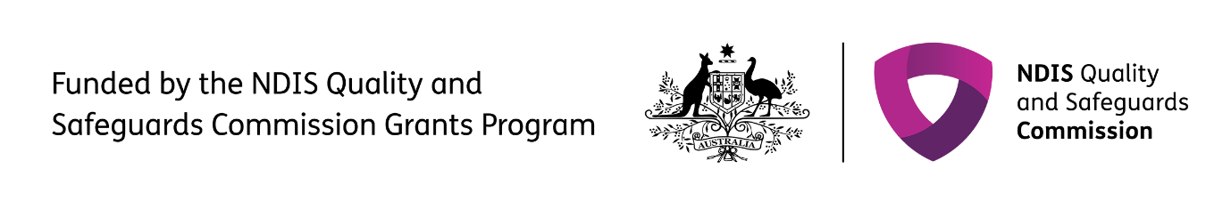The right direction logo - Working together on positive behaviour support (PBS).


Published in 2025