Deciding how involved I want to be in my behaviour support planning



A tool for behaviour support practitioners and participants

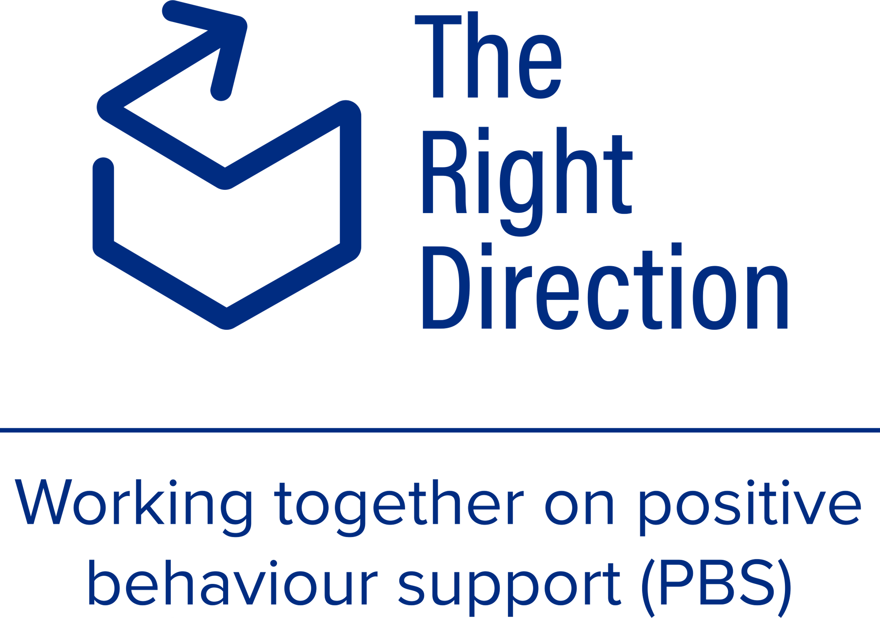

## Getting it right: Using the scale to decide how involved participants want to be

### Instructions for behaviour support practitioners

This tool facilitates behaviour support practitioners working together with behaviour support participants to decide how involved the participant would like to be in their behaviour support planning.

Practitioners will know this guide as ‘the Spectrum of Participation’, however participants, family members and other members of the support network are more likely to connect with plain language. As such, this document uses the word ‘scale’ (rather than spectrum).

Effective behaviour support planning relies on the people you will use this scale with (people with disability and their support network) understanding the goal of the scale and the choices it provides.

This visual tool helps behaviour support practitioners work with participants to talk about the scale and choose the level of participation that suits the participant’s wants and needs for their behaviour support planning process.

This resource helps behaviour support practitioners:

* explain the Spectrum of Participation for behaviour support planning in an accessible way,
* have a conversation with a participant about their wishes and needs for their behaviour support planning process,
* support a participant in choosing their level of involvement in the behaviour support planning process (and that of their support network), and
* assess and measure changes over time in both the participant’s *wish* to participate and *their experience* participation in their behaviour support planning process.

### What is included in this resource?

This resource includes two scales that can be used as conversation cards. They have pictures explaining the scale to hep participants show how involved they want to be in their behaviour support planning.

Each card is a visual scale has a different question to explore with participants:

1. How involved **do you want to be** in your behaviour support planning?, and
2. How involved **have you been** before in your behaviour support planning?

### Steps for using this resource

1. Start with a conversation with the participant at the very beginning of the behaviour support process to find out how involved they want to be in their planning.
2. You may wish to use the easy read document [How involved do I want to be in my behaviour support planning?](https://therightdirectionpbs.com/downloads/spectrum-of-participation/spectrum_of_participation_easy_read.docx) to:

a) discuss further and ask questions of the participant,

b) speak further with their support network members, and

c) use your understanding of the participant’s wishes based on previous discussion to judge which level they are choosing.

1. Check-in with the person at key times during the planning process to see if they have changed their mind about how involved they want to be.
2. Record the level and note any changes as you check-in on different occasions.
3. Ask the person to comment on why they gave you the answer they did. Ask the person about any changes from last time if you notice a move up or down. Differences between the participant’s desired involvement and previous experience of involvement may reflect issues with the behaviour support planning process.
4. Use this information as your guide for when and how to involve the person (and others) in their behaviour support plan. This information will also be a prompt for you to identify any communication issues and ensure the participant is included according to their wishes.
5. Use this information when discussing with others about when and how to involve the person in their behaviour support plan.

### How involved do I want to be in my behaviour support planning?

Note for behaviour support practitioners: Ask the person to show you how involved they’d like to be by pointing to the level of participation. Record this and check in to monitor changes over time.

|  |
| --- |
| I want to say what’s in my behaviour support plan    Very included |
| I want to be part of the team who talk about my behaviour support plan    Partly included |
| I just want people to tell me about my behaviour support plan |

I don’t want to give ideas for my behaviour support plan   
(my support network can help write it for me)



Not included for now

### How involved have I been before in my behaviour support planning?

Note for behaviour support practitioners: Only use this option for people who have had previous or existing behaviour support plans.

Ask the person to show you how involved they’d like to be by pointing to the level of participation. Check in to monitor changes over time and compare what was intended with the person’s experience of being included.

|  |
| --- |
| I always got to say what’s in my behaviour support plan    Very included |
| I was part of a team who says what’s in my behaviour support plan    Partly included |
| People only told me about my behaviour support plan |

No one has ever asked me about my behaviour support plan



Not included at that time



Images may not be reused



**therightdirectionpbs.com**

|  |
| --- |
|  |

The right direction logo - Working together on positive behaviour support (PBS).


Published in 2025