Communicating about   
restrictive practices



Large picture cards template (A4 customisable)

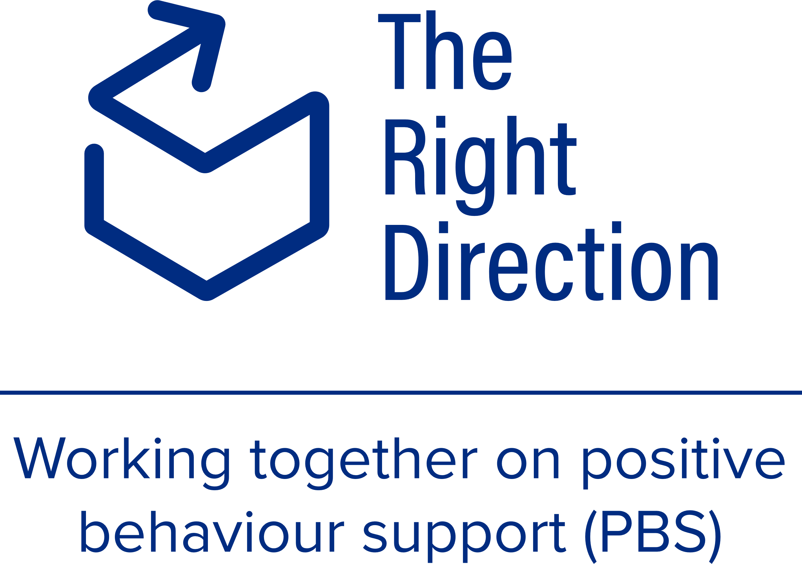

### How to use these cards – instructions for practitioners

Before using these cards, read our page on [communicating about restrictive practices](https://therightdirectionpbs.com/resources/restrictive-practices) and watch our video about [using discussion mats](https://therightdirectionpbs.com/resources/using-discussion-mats#video).

These picture cards are designed to be used with a discussion mat and match our [example discussion mat for restrictive practices](https://therightdirectionpbs.com/downloads/restrictive-practices/restrictive_practices_example_discussion_mat_A3.docx), but they can be used in any way you find helpful in your behaviour support practice.

You may wish to use our [customisable discussion mat template](https://therightdirectionpbs.com/downloads/using-discussion-mats/different_communication_techniques_discussion_mat_and_picture_cards_template_A3.docx) so that you can use the blank mat together when discussing behaviours of concern with your participant.

To use these cards, print them on A4 paper and cut them out. You may choose to laminate them or use thick paper so that they last longer.

Before going to see your behaviour support participant, you can also use our [customisable picture card templates](https://therightdirectionpbs.com/resources/using-discussion-mats) to create cards you know will be relevant to the participant, using pictures, photos or words.

### Other useful resources include:

Guides:

* [Communicating about behaviours of concern: Using discussion mats](https://therightdirectionpbs.com/resources/behaviours-of-concern),
* [Communicating about restrictive practices: Using discussion mats](https://therightdirectionpbs.com/resources/restrictive-practices), and
* [Different communication techniques: Using discussion mats](https://therightdirectionpbs.com/resources/using-discussion-mats#video) (video)

Picture cards:

* Communicating about behaviours of concern picture cards  
  ([A4 discussion mat size](https://therightdirectionpbs.com/downloads/behaviours-of-concern/behaviours_of_concern_picture_cards_A4.docx), [A4 large size](https://therightdirectionpbs.com/downloads/behaviours-of-concern/behaviours_of_concern_large_picture_cards_A4.docx)),
* Communicating about restrictive practices picture cards  
  ([A4 discussion mat size](https://therightdirectionpbs.com/downloads/restrictive-practices/restrictive_practices_picture_cards_A4.pdf), [A4 large size](https://therightdirectionpbs.com/downloads/restrictive-practices/restrictive_practices_large_picture_cards_A4.pdf)),
* [A4 template](https://therightdirectionpbs.com/downloads/behaviours-of-concern/behaviours_of_concern_picture_cards_A4.docx)(our discussion-mat template size),
* [A4 template](https://therightdirectionpbs.com/downloads/using-discussion-mats/different_communication_techniques_picture_cards_template_A4.docx) (large-size cards), and
* [A3 template](https://therightdirectionpbs.com/downloads/using-discussion-mats/different_communication_techniques_large_picture_cards_template_A4.docx) (discussion-mat template size).

Discussion mats:

* [Example mat for discussing behaviours of concern](https://therightdirectionpbs.com/downloads/behaviours-of-concern/behaviours_of_concern_example_discussion_mat_A3.docx),
* [Example mat for discussing restrictive practices](https://therightdirectionpbs.com/downloads/restrictive-practices/restrictive_practices_example_discussion_mat_A3.docx), and
* [Discussion mat template](https://therightdirectionpbs.com/downloads/using-discussion-mats/different_communication_techniques_discussion_mat_and_picture_cards_template_A3.docx).

These cards support the ideas in the [example discussion mat for discussing restrictive practices](https://therightdirectionpbs.com/downloads/behaviours-of-concern/behaviours_of_concern_example_discussion_mat_A3.docxhttps:/therightdirectionpbs.com/downloads/behaviours-of-concern/behaviours_of_concern_example_discussion_mat_A3.docx). They can be used together with the [example discussion mat](https://therightdirectionpbs.com/downloads/behaviours-of-concern/behaviours_of_concern_example_discussion_mat_A3.docxhttps:/therightdirectionpbs.com/downloads/behaviours-of-concern/behaviours_of_concern_example_discussion_mat_A3.docx) and card templates for discussing behaviours of concern ([A4 discussion mat size](https://therightdirectionpbs.com/downloads/behaviours-of-concern/behaviours_of_concern_picture_cards_template_A4.docx), [A4 large size](https://therightdirectionpbs.com/downloads/behaviours-of-concern/behaviours_of_concern_large_picture_cards_template_A4.docx)).

### If I’m still upset by

|  |  |
| --- | --- |
| Type words here (or delete this box) |  |
|  |  |

|  |  |
| --- | --- |
| Type words here (or delete this box) |  |
|  |  |

### If I’m still upset by

|  |  |
| --- | --- |
| Type words here (or delete this box) |  |
|  |  |

### I might need this

|  |  |
| --- | --- |
| Type words here (or delete this box) |  |
|  |  |

### I might need this

|  |  |
| --- | --- |
| Type words here (or delete this box) |  |
|  |  |

### Until

### Until

|  |  |
| --- | --- |
| Type words here (or delete this box) |  |
|  |  |





Published in 2025

**therightdirectionpbs.com**