Communicating about restrictive practices



## Using discussion mats

The right direction logo - Working together on positive behaviour support (PBS).


# Communicating about restrictive practices

## Using discussion mats

This resource is best used together with [communicating about behaviours of concern](https://therightdirectionpbs.com/resources/behaviours-of-concern).

As a practitioner, an important and delicate part of engaging with people with disability about behaviours of concern can be talking about restrictive practices, explaining what they are, why they may be necessary and deciding on a plan for how they will be used when they are required.

[A discussion mat](https://therightdirectionpbs.com/resources/using-discussion-mats) can be [a useful and adaptable tool](https://therightdirectionpbs.com/resources/using-discussion-mats#video) for exploring how restrictive practices might be necessary when behaviours of concern escalate and people become unsafe.

Engaging the person in exploring the cause and effect of their behaviours of concern and also how to best manage any safety concerns is a crucial part of the behaviour support process and it is [the person’s right](https://therightdirectionpbs.com/resources/communication-rights) to be [as involved in this process](https://therightdirectionpbs.com/resources/spectrum-of-participation) as they wish to be.

## Instructions for behaviour support practitioners

As a behaviour support practitioner, you may find using discussion mats to talk about restrictive practices helpful. You should use a discussion mat with the participant and any trusted person who they have chosen to be part of the discussion.

This conversation will usually continue on from your [conversation about behaviours of concerns](https://therightdirectionpbs.com/resources/behaviours-of-concern), perhaps after a break.

### What does this discussion mat include?

Use the [example discussion mat for talking about restrictive practices](https://therightdirectionpbs.com/downloads/restrictive-practices/restrictive_practices_example_discussion_mat_A3.docx) to guide your conversation or create your own discussion mat using other materials. You can also customise The Right Direction [discussion mat and picture cards template (A3)](https://therightdirectionpbs.com/downloads/using-discussion-mats/different_communication_techniques_picture_cards_template_A3.docx).

The example board has three columns:

1. **If I’m still upset by...**   
   (This reminds you of the ‘triggers’ for the behaviour of concern)
2. **I might need this...**   
   (This relates to the least invasive option for what others might do to ensure everyone is safe during the behaviour of concern, including for how long)
3. **Until...**   
   (This relates to when the person and others can judge that the person is calming to safer levels and the behaviour of concern is no longer unsafe. It may also include an option for judging when this technique is not helping and another should be tried.)

### What else do I need to consider first?

Remember that ‘restrictive practices limit a person’s freedom and should be used as a last resort when positive support strategies fail to ensure safety’ (NDIS Quality and Safeguards Commission, 2024). ***The goal is always to reduce or eliminate the need for restrictive practice.***

The option cards provided with this resource include examples of restrictive practice. This is not an endorsement of or recommendation these practices.

Be aware of the sensitive nature of this discussion.   
Carefully consider the following factors when setting up the conversation:

* time,
* place,
* who should be there,
* additional supports that would help (e.g., additional visual supports such as an anger scale).

### How do I get started with the discussion mat?

These are conversation starters, which you discuss one after another, to lead you through the process of escalating behaviours of concern and how best to manage the behaviour of concern so everyone remains safe.

In some cases, the discussion about restrictive practices will directly follow the discussion about behaviours of concern. To allow for this, you may wish to familiarise yourself with the following information as part of your preparation and being what you need to the meeting with the participant.

* [Communicating about behaviours of concern: Picture cards](https://therightdirectionpbs.com/downloads/behaviours-of-concern/behaviours_of_concern_picture_cards_A4.pdf)
* [Communicating about behaviours of concern: Large picture cards](https://therightdirectionpbs.com/downloads/behaviours-of-concern/behaviours_of_concern_large_picture_cards_A4.pdf)
* [Different communication techniques: Using discussion mats (video)](https://therightdirectionpbs.com/resources/using-discussion-mats#video)

In terms of using the [communicating about restrictive practices example discussion mat](https://therightdirectionpbs.com/downloads/restrictive-practices/restrictive_practices_example_discussion_mat_A3.docx), the mat itself has several examples of how the discussion might progress that you can draw on.

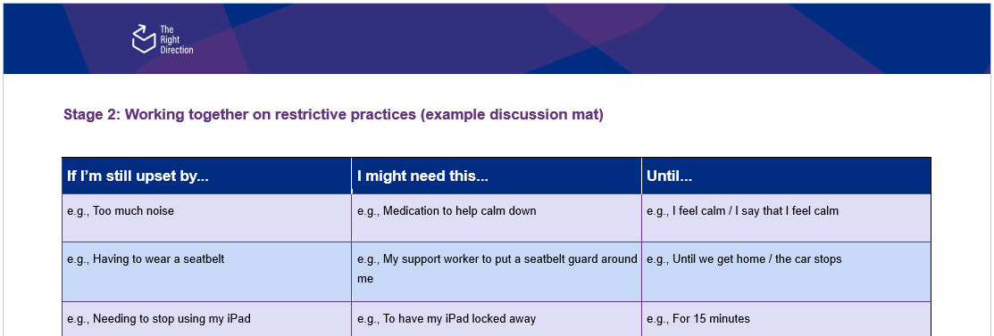Here is an example of what you’ll see in the discussion mat for discussing restrictive practices.

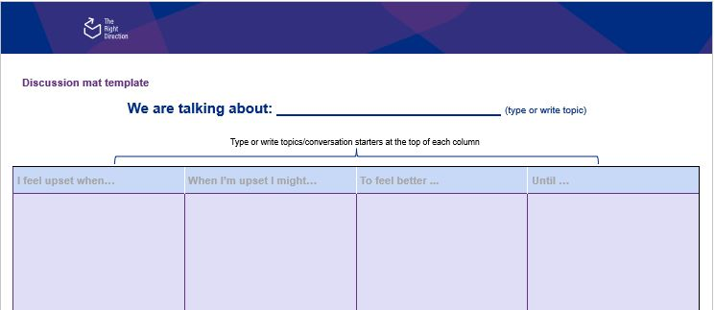  
You may wish to use [our discussion mat template](https://therightdirectionpbs.com/downloads/using-discussion-mats/different_communication_techniques_picture_cards_template_A3.docx), so you have a blank version to complete according to your needs.

Prepare picture cards with possible examples/options for each column. We have several examples you may wish to use, including:

* [Communicating about restrictive practices: Picture cards](https://therightdirectionpbs.com/downloads/restrictive-practices/restrictive_practices_picture_cards_A4.pdf)
* [Communicating about restrictive practices: Large picture cards](https://therightdirectionpbs.com/downloads/restrictive-practices/restrictive_practices_large_picture_cards_A4.pdf)
* 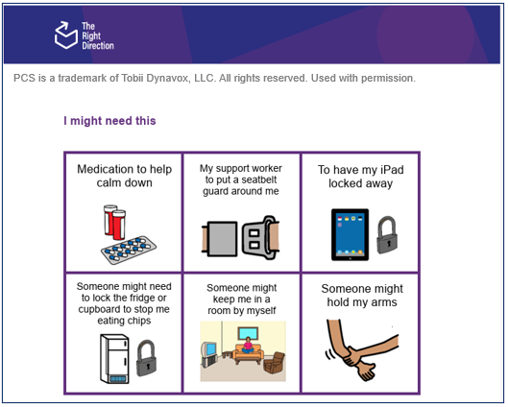[Different communication techniques: Picture card templates](https://therightdirectionpbs.com/resources/using-discussion-mats)

The images above provide an example of the picture cards available for the restrictive practices discussion mat. You should bring some blank cards to create other options if you need them, by drawing onto the paper or writing key words in the columns, depending on what works best in the moment.

### The conversation

Using the discussion mat is reasonably simple, once you become familiar with it.

Each column progresses the discussion toward the decision – in this case, reminding yourselves of the trigger, what restrictive practices are available to keep the person and others safe, how long it will last for and how everyone will know if it is either calming the person or not working (and another technique should be tried).

### If I’m still upset by...

To use this column:

* Remind the participant what things you were talking about that might make them upset, and what you agreed would be tried as self-soothing.
* Explain that this section is to discuss what to do if the person still feels triggered after trying the self-soothing option or if they or others are in an unsafe situation.
* Show the relevant option cards to the person and together choose the one that relates to the trigger you’re discussing. If the person suggests another option, write/draw this on a blank card.
* Place the relevant option cards on the board in the ‘If I’m still upset by…’ column.

### I might need this…

To use this column:

* Make clear to the participant that the proposed response is a restrictive practice and [they have the right to choose](https://therightdirectionpbs.com/resources/communication-rights).  
  You might say: “Everyone that lives/works with you cares about you and wants to make you feel better when you’re upset. I want to talk about the things you do or that others do/could do to make you feel better when you’re upset still upset after trying [X – self-soothing].”
* Show the relevant option cards to the person.
* Ask the participant how they feel about the proposed restrictive practice.   
  Consider using [a visual rating scale](https://therightdirectionpbs.com/downloads/toward-your-goals/visual_rating_scale_template) that allows the person to indicate how they feel (eg: okay, might be okay/I’m not sure, not okay).
* Remind the participant they can disagree and propose alternatives. Explain that the blank cards can be used to add other options. If the person suggests another option, write/draw this on a blank card.
* You might say to summarise: “If you still fee upset and [Y – the behaviour] becomes unsafe, we could do [Z] to help you to feel better.”
* Place relevant card on the board in the ‘I might need this…’ column.

### Until...

To use this column:

* Show the relevant option cards to the person. Explain that the blank cards can be used to add other options. If the person suggests another option, write/draw this on a blank card.
* Place relevant card on the board in the ‘Until…’ column.
* You might say: “It’s helpful to know when you feel better after becoming upset. I need to find out what this looks like for you and also what this looks like when it’s **not working** for you. If it’s not working, we can stop this and try another option.”
* Show the relevant option cards to the person. Explain that the blank cards can be used to add other options. If the person suggests another option, write/draw this on a blank card.
* Place relevant option card on the board in the ‘Until…’ column. Include this both for when the person is feeling calmer, a maximum length of time, and also when to know it’s clearly not working and should be stopped and another technique tried.
* You might say to summarise: “We would [Z – the thing that makes the person feel better] until [certain goal is achieved], or for [specified time period].”

You can find some further examples on the [example discussion mat for talking about restrictive practices](https://therightdirectionpbs.com/downloads/restrictive-practices/restrictive_practices_example_discussion_mat_A3.docx).

You can also watch a short video about how to use discussion mats or [talking about restrictive practices (overview)](https://therightdirectionpbs.com/resources/restrictive-practices#video) or [advice from peers](https://therightdirectionpbs.com/resources/restrictive-practices#video-advice-from-peers).



**therightdirectionpbs.com**

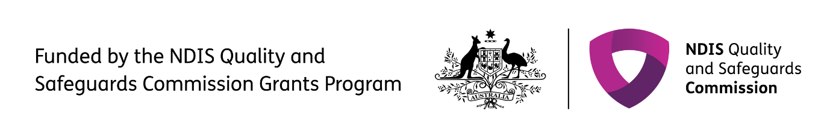The right direction logo - Working together on positive behaviour support (PBS).


Published in 2025