Communicating about restrictive practices



## Example discussion mat

The right direction logo - Working together on positive behaviour support (PBS).


## Instructions for behaviour support practitioners

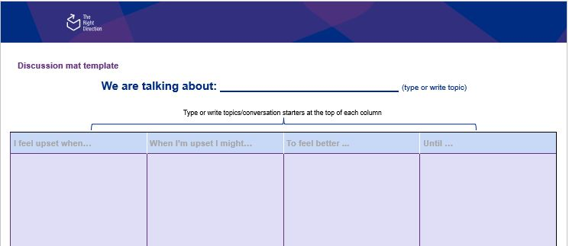This is an example discussion mat for behaviour support practitioners to use when talking about restrictive practices. It includes some strategies that can be useful during the behaviour support planning process.

You can use it either for your own information or as a tool to use with behaviour support participants. You can use this example mat it aligns with the needs of the participant’s needs or customise it to suit the individual needs of each participant.

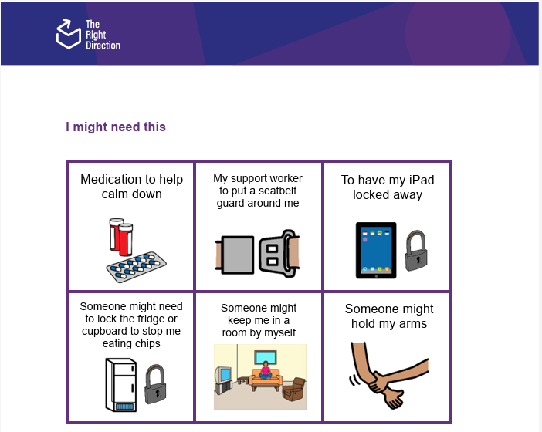This Word document is editable to allow you to change it as you need. [The Right Direction website](https://therightdirectionpbs.com/) also provides an editable [Word-based discussion mat and picture card template](https://therightdirectionpbs.com/downloads/using-discussion-mats/different_communication_techniques_discussion_mat_and_picture_cards_template_A3.docx) for you to make your own mat, and word, picture or photo-based cards according to your needs and uses.

PCS is a trademark of Tobii Dynavox, LLC. All rights reserved. Used with permission.

[Download the discussion mat template](https://therightdirectionpbs.com/downloads/using-discussion-mats/different_communication_techniques_discussion_mat_and_picture_cards_template_A3.docx) (customisable for your topic)

For this example discussion mat about restrictive practices, you can also download and print [matching picture cards (A4)](https://therightdirectionpbs.com/downloads/behaviours-of-concern/behaviours_of_concern_picture_cards_A4.pdf) and [larger matching picture cards (A4)](https://therightdirectionpbs.com/downloads/behaviours-of-concern/behaviours_of_concern_large_picture_cards_A4.pdf), if needed.

You should use it as a second step, after discussing behaviours of concern. The Right Direction also includes an [example mat for discussing behaviours of concern](https://therightdirectionpbs.com/downloads/behaviours-of-concern/behaviours_of_concern_example_discussion_mat_A3.docx), with [matching picture cards (A4)](https://therightdirectionpbs.com/downloads/behaviours-of-concern/behaviours_of_concern_picture_cards_A4.pdf) and [larger matching picture cards (A4)](https://therightdirectionpbs.com/downloads/behaviours-of-concern/behaviours_of_concern_large_picture_cards_A4.pdf).

You can also watch The Right Direction videos on [communicating about restrictive practices (overview)](https://therightdirectionpbs.com/resources/restrictive-practices#video) and [communicating about restrictive practices: advice from peers](https://therightdirectionpbs.com/resources/restrictive-practices#video-advice-from-peers).

Restrictive practice [matching picture cards (A4)](https://therightdirectionpbs.com/downloads/restrictive-practices/restrictive_practices_picture_cards_A4.pdf)   
and [larger matching picture cards (A4)](https://therightdirectionpbs.com/downloads/restrictive-practices/restrictive_practices_large_picture_cards_A4.pdf)

**Stage 2: Working together on restrictive practices (example discussion mat)**

|  |  |  |
| --- | --- | --- |
| If I’m still upset by... | I might need this... | Until... |
| e.g., Too much noise | e.g., Medication to help calm down | e.g., I feel calm / I say that I feel calm |
| e.g., Having to wear a seatbelt | e.g., My support worker to put a seatbelt guard around me | e.g., Until we get home / the car stops |
| e.g., Needing to stop using my iPad | e.g., To have my iPad locked away | e.g., For 15 minutes |
| e.g., Not being allowed to eat chips because of my special diet | e.g., Someone might need to lock the fridge cupboard to stop me from eating chips | e.g., We can remove the chips from the cupboard |
| e.g., People coming into my room without asking if it’s okay to | e.g., Someone might keep me in a room by myself | e.g., For 15 minutes or I feel calm./ I say I feel calm |
| e.g., Being in a crowd | e.g., Someone might hold my arms | e.g., Until I stop trying to push people |
| e.g., My routine changing without people telling me | e.g., Medication to help calm down | e.g., For 5 minutes or Until I feel calm |

The right direction logo - Working together on positive behaviour support (PBS).


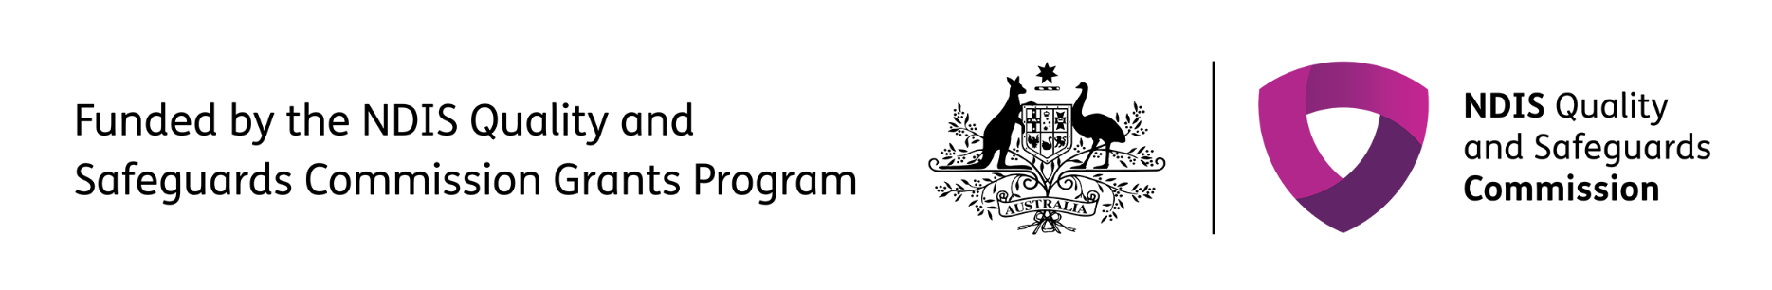

**therightdirectionpbs.com**

Published in 2025