Including my support network in my plan



## Working together on how best to engage participants’ support networks in behaviour support planning

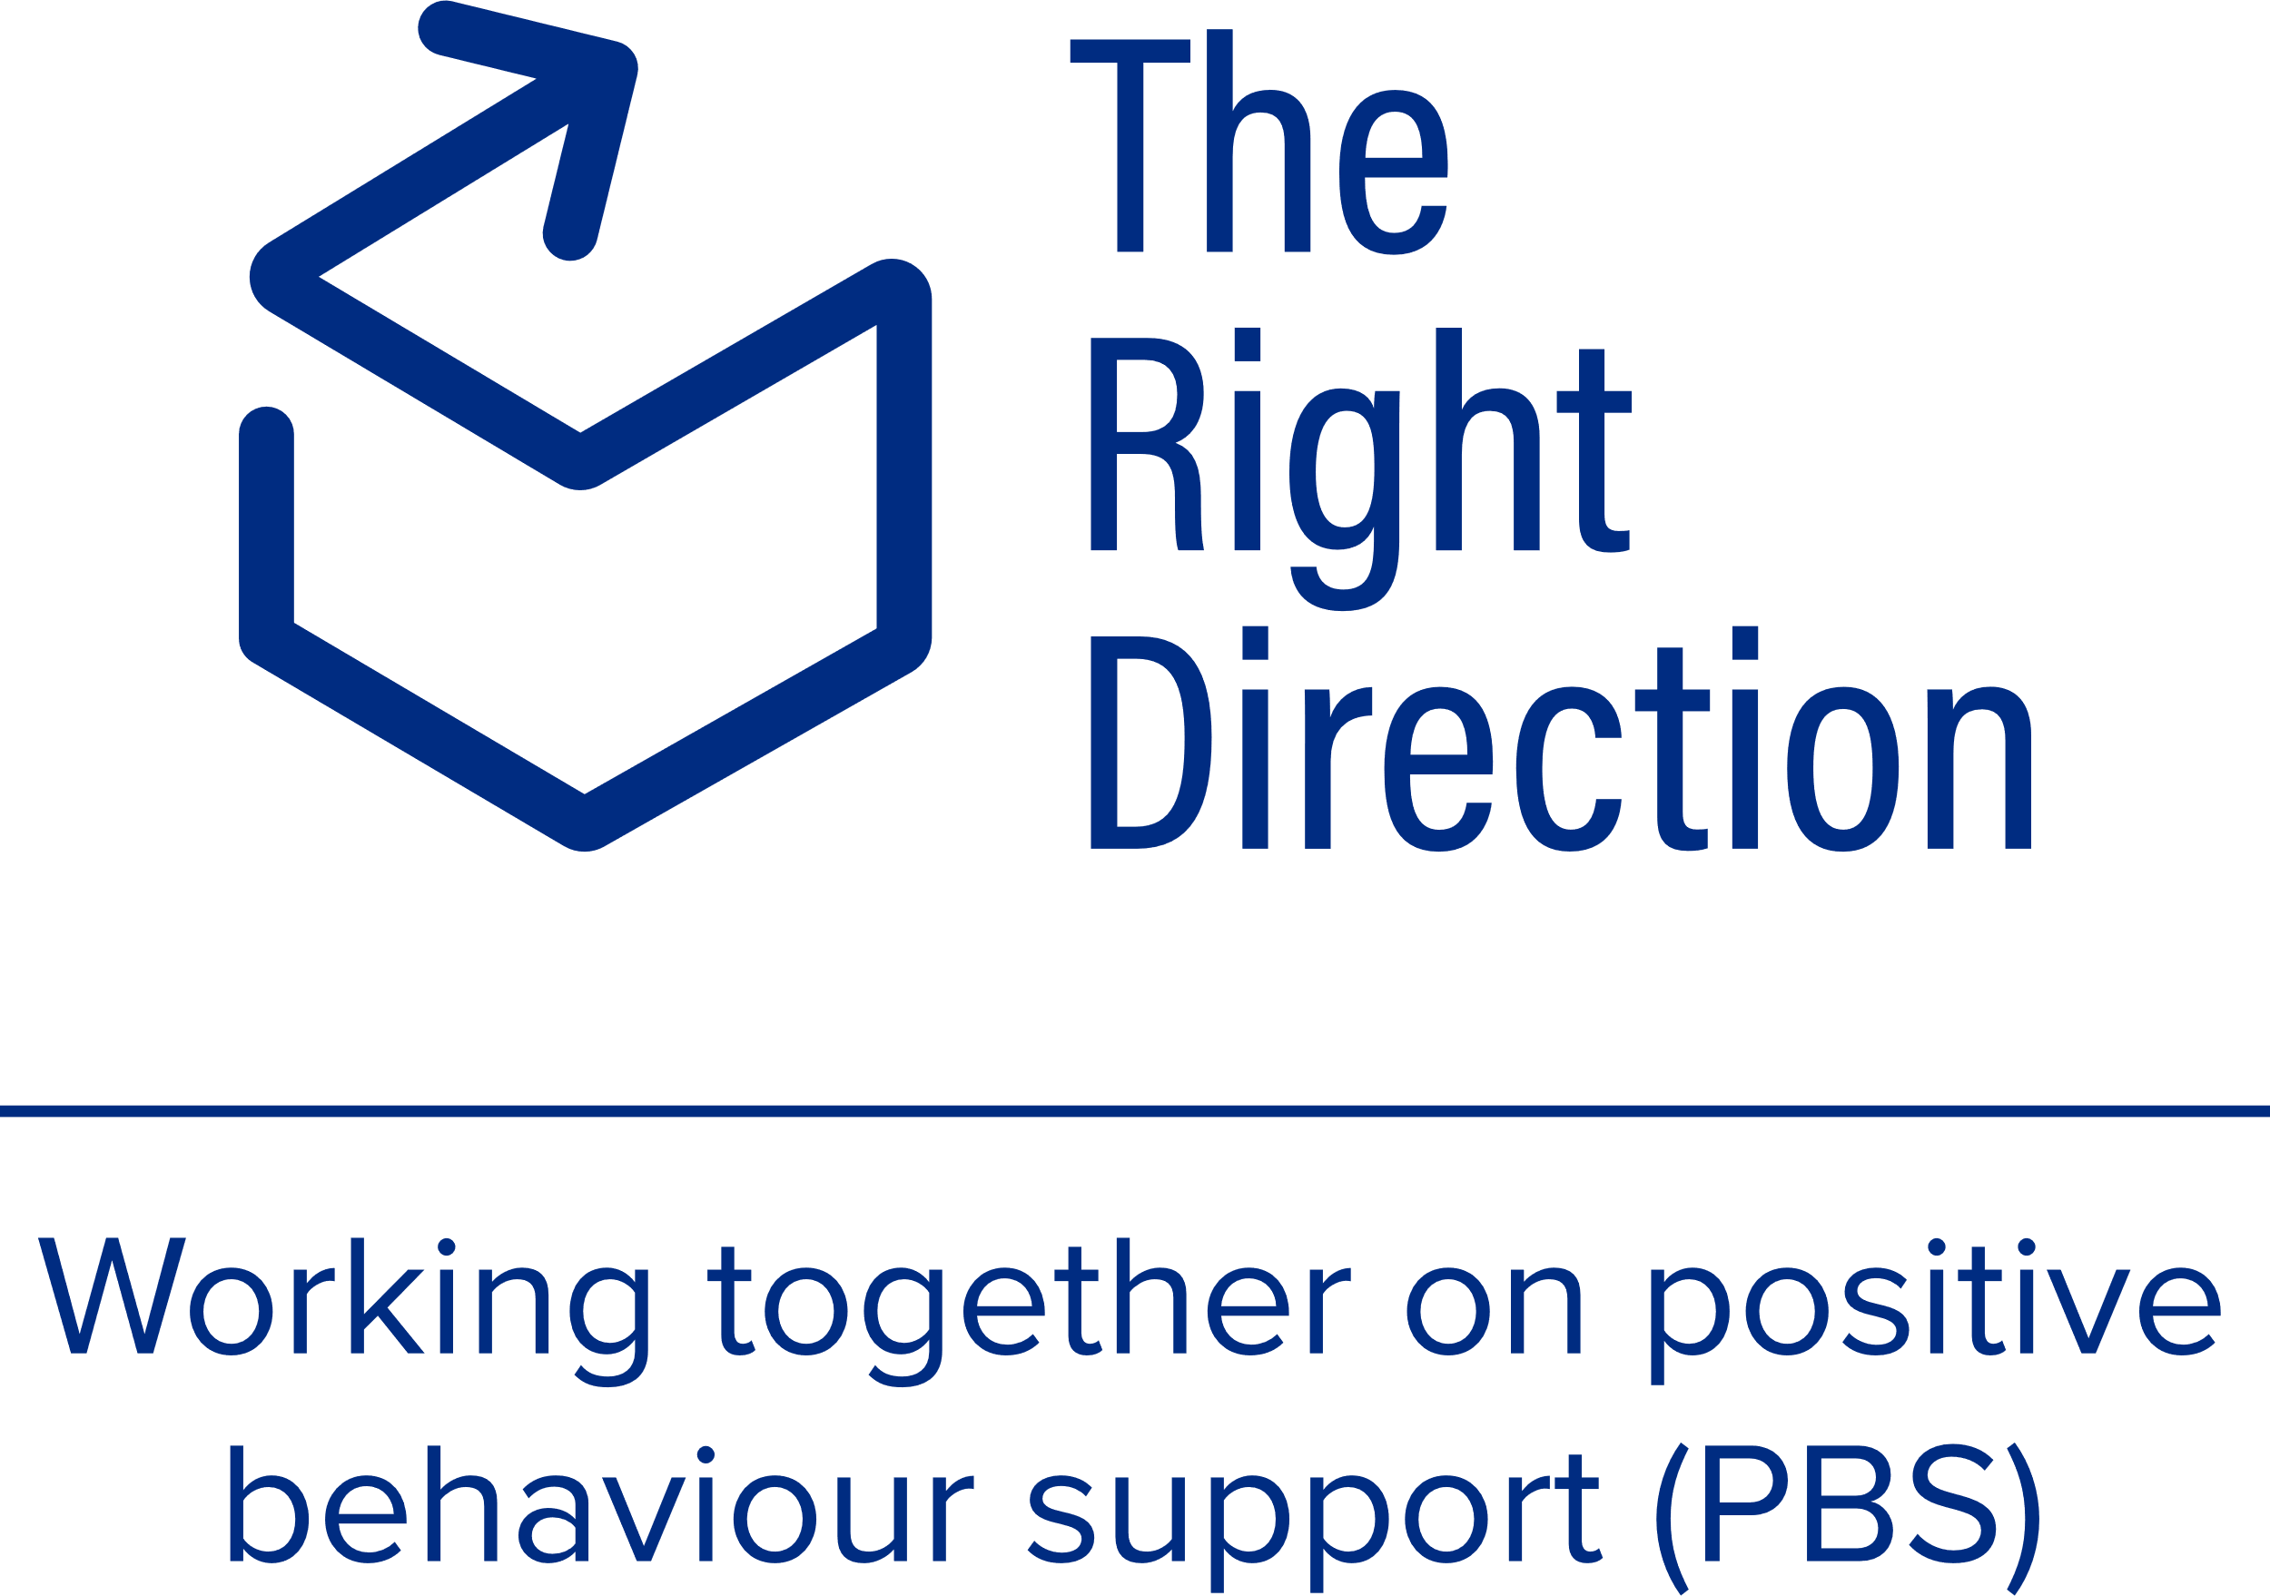

## Instructions for behaviour support practitioners

This template is for behaviour support practitioners to work through together with behaviour support participants to understand how best to engage the participant’s support network in their behaviour support plan.

The goal is to unite the right people as part of this plan, to help the participant reach [the goals for their behaviour support plan](https://therightdirectionpbs.com/resources/behaviour-support-goals) and progress toward [their goals for a good life](https://therightdirectionpbs.com/resources/my-good-life-goals).

Please edit this workbook if you need to, so that it suits your participant’s unique situation.

The workbook could form part of the formal documentation you use to demonstrate how you engaged with the person at the beginning of the planning process, and how you gained consent for others to be involved. But remember the workbook is designed to be the person’s record and you should consider leaving them with the original and getting a copy for your own records.

### Tips for effective engagement during the consent planning process

Remember the following tips for effective engagement:

* **focus on rights** – keep the poster [My communication rights](https://therightdirectionpbs.com/downloads/communication-rights/my_communication_rights_poster.pdf) prominent in the space.
* **remind the participant** **it is okay** if they have a different opinion and you care about what they think and feel.
* **show the person** **you respect them** and their choices by listening, responding to their ideas and thoughts, and taking them seriously.
* **work at the person’s pace** – respect their needs and make decisions across multiple sessions if needed.
* **use trauma-informed language** – gentle, validating and strengths-focused.
* **avoid assumptions** – check in regularly to confirm, ‘Is this right?’ or, ‘How does this sound to you?’.
* **be curious** – demonstrate interest in the person and what’s important for them. Try phrases such as, ‘That’s interesting, tell me more about that.’
* **celebrate their choices** – this is a real plan to support their life goals, not just paperwork.

## What’s in this workbook

1. **About me**

This section builds the participant’s ownership and connection to the plan.

1. **My most trusted people**

Before you start this section, consider using the [Hand of Trust](https://therightdirectionpbs.com/resources/your-support-network#hand-of-trust) and [My support network: What does it look like?](https://therightdirectionpbs.com/resources/your-support-network#participants-relationship-to-support-network) from The Right Direction website if these tools are useful in talking about who the participant trusts most in their support network and why.

These can be helpful tools for discussing who is in the person’s support network, who the most trusted people are, why they are trusted people and who will be best to help with particular needs and situations.

Consider if using photos might help the person better understand and talk about who might be involved. You could ask the person to draw their own picture of each person they want to have involved. These images can then be included in the workbook.

The activity in this document differs from these 2 activities in that it progresses the planning process by focusing specifically on identifying the trusted people **who will be involved in their behaviour support plan** to help meet the participant’s behaviour support needs.

1. **Other people in my support network who can help me**

Building on the discussions you have had with the participant about their behaviour support needs, for example by using the discussion mats on our website ([communicating about behaviours of concern](https://therightdirectionpbs.com/resources/behaviours-of-concern) and – only if needed – [communicating about restrictive practices](https://therightdirectionpbs.com/resources/restrictive-practices)) list what the person needs help with and how others can support them best.

1. **Do I consent (understand and agree)?**

You will need both the participant’s and the people in the support network’s permission for others to be involved in the behaviour support plan.

To do this, you might:

* explain to the participant why you need permission from others to be involved in the behaviour support plan (eg: you could say, ‘Before anyone helps with your plan, they need to know what they will be asked to do and to say ‘yes’ to helping. You help choose who that is.’
* fill in the names together and ask if it’s okay for this person to be involved and asked for their permission. Again, photos or the person’s own drawing could be helpful to use at this point.
* if the participant wants to ask the people in their support network’s permission, support the person in doing this. Alternatively, you can ask the key people from the support network’s permission on the participant’s behalf, with their consent.
* if the participant is able to sign their consent, ask them to do so and keep the documentation private and safe. Alternatively, you might record audio or video of the session, if appropriate; or you might have an advocate or independent person involved, who can help to establish consent in line with [the participant’s rights](https://therightdirectionpbs.com/resources/communication-rights) and wishes.

# Including my support network in my behaviour support plan

A workbook for behaviour support practitioners and behaviour support participants to do together.

About me

My name:__________________________________________________

Today’s date: ______________________________________________

The name of the person helping me with these questions (the behaviour support practitioner): ________________________________________

My most trusted people

1. Who are my most trusted people?

These are the people who help me feel safe, happy and supported.

They can be family, friends, teachers, support workers or others.

Name: ____________________________________________________

How they support me: _______________________________________

_________________________________________________________

Contact details (optional): _____________________________________

Name: ____________________________________________________

How they support me: _______________________________________

_________________________________________________________

Contact details (optional): _____________________________________

Name: ____________________________________________________

How they support me: _______________________________________

_________________________________________________________

Contact details (optional): _____________________________________

1. Who do I trust the most to help me with my behaviour support plan?

_________________________________________________________

_________________________________________________________

_________________________________________________________

_________________________________________________________

_________________________________________________________

_________________________________________________________

1. Who do I talk to when I need help?

_________________________________________________________

_________________________________________________________

_________________________________________________________

1. Who helps me feel calm when I am upset?

_________________________________________________________

_________________________________________________________

_________________________________________________________

1. Who do I want to help me with my support plan?

_________________________________________________________

_________________________________________________________

_________________________________________________________

Other people in my support network who can help me

I need help when:

_________________________________________________________

_________________________________________________________

_________________________________________________________

_________________________________________________________

_________________________________________________________

The best way to help me is: _________________________________________________________

__________________________________________________

__________________________________________________

__________________________________________________

__________________________________________________

The best person / people to help me is:

_________________________________________________________

__________________________________________________

__________________________________________________

__________________________________________________

__________________________________________________

Do I consent (understand and agree)?

It is my plan. It is about my life and my goals. I can say, ‘Yes’ or, ‘No’ to this plan and who helps me with it.

Consent means people understand the plan and say, ‘Yes’ to being part of it.

**Tick to say**   
 Yes or No

Do I want these people to help me with my plan?

Name of person: _____________________________________

Name of person: _____________________________________

Name of person: _____________________________________

Name of person: _____________________________________

Name of person: _____________________________________

Yes or No

I feel that my support network is here to help me.

I know I can change the people I choose to help me with my plan.

I know how to contact my behaviour support practitioner for   
help with my plan.

**Does my support network consent?**

Before anyone in my support network can help with my behaviour support plan, they also need to say, ‘Yes, they want to be part of helping with my plan’.

Yes or No

These people have said, ‘Yes’ and want to help with my plan:

Name of person & date: _______________________________

Name of person & date: _______________________________

Name of person & date: _______________________________

Name of person & date: _______________________________

Name of person & date: _______________________________



Images may not be reused



**therightdirectionpbs.com**

Published in 2025