Getting to know each other  
Editable conversation cards (A4)



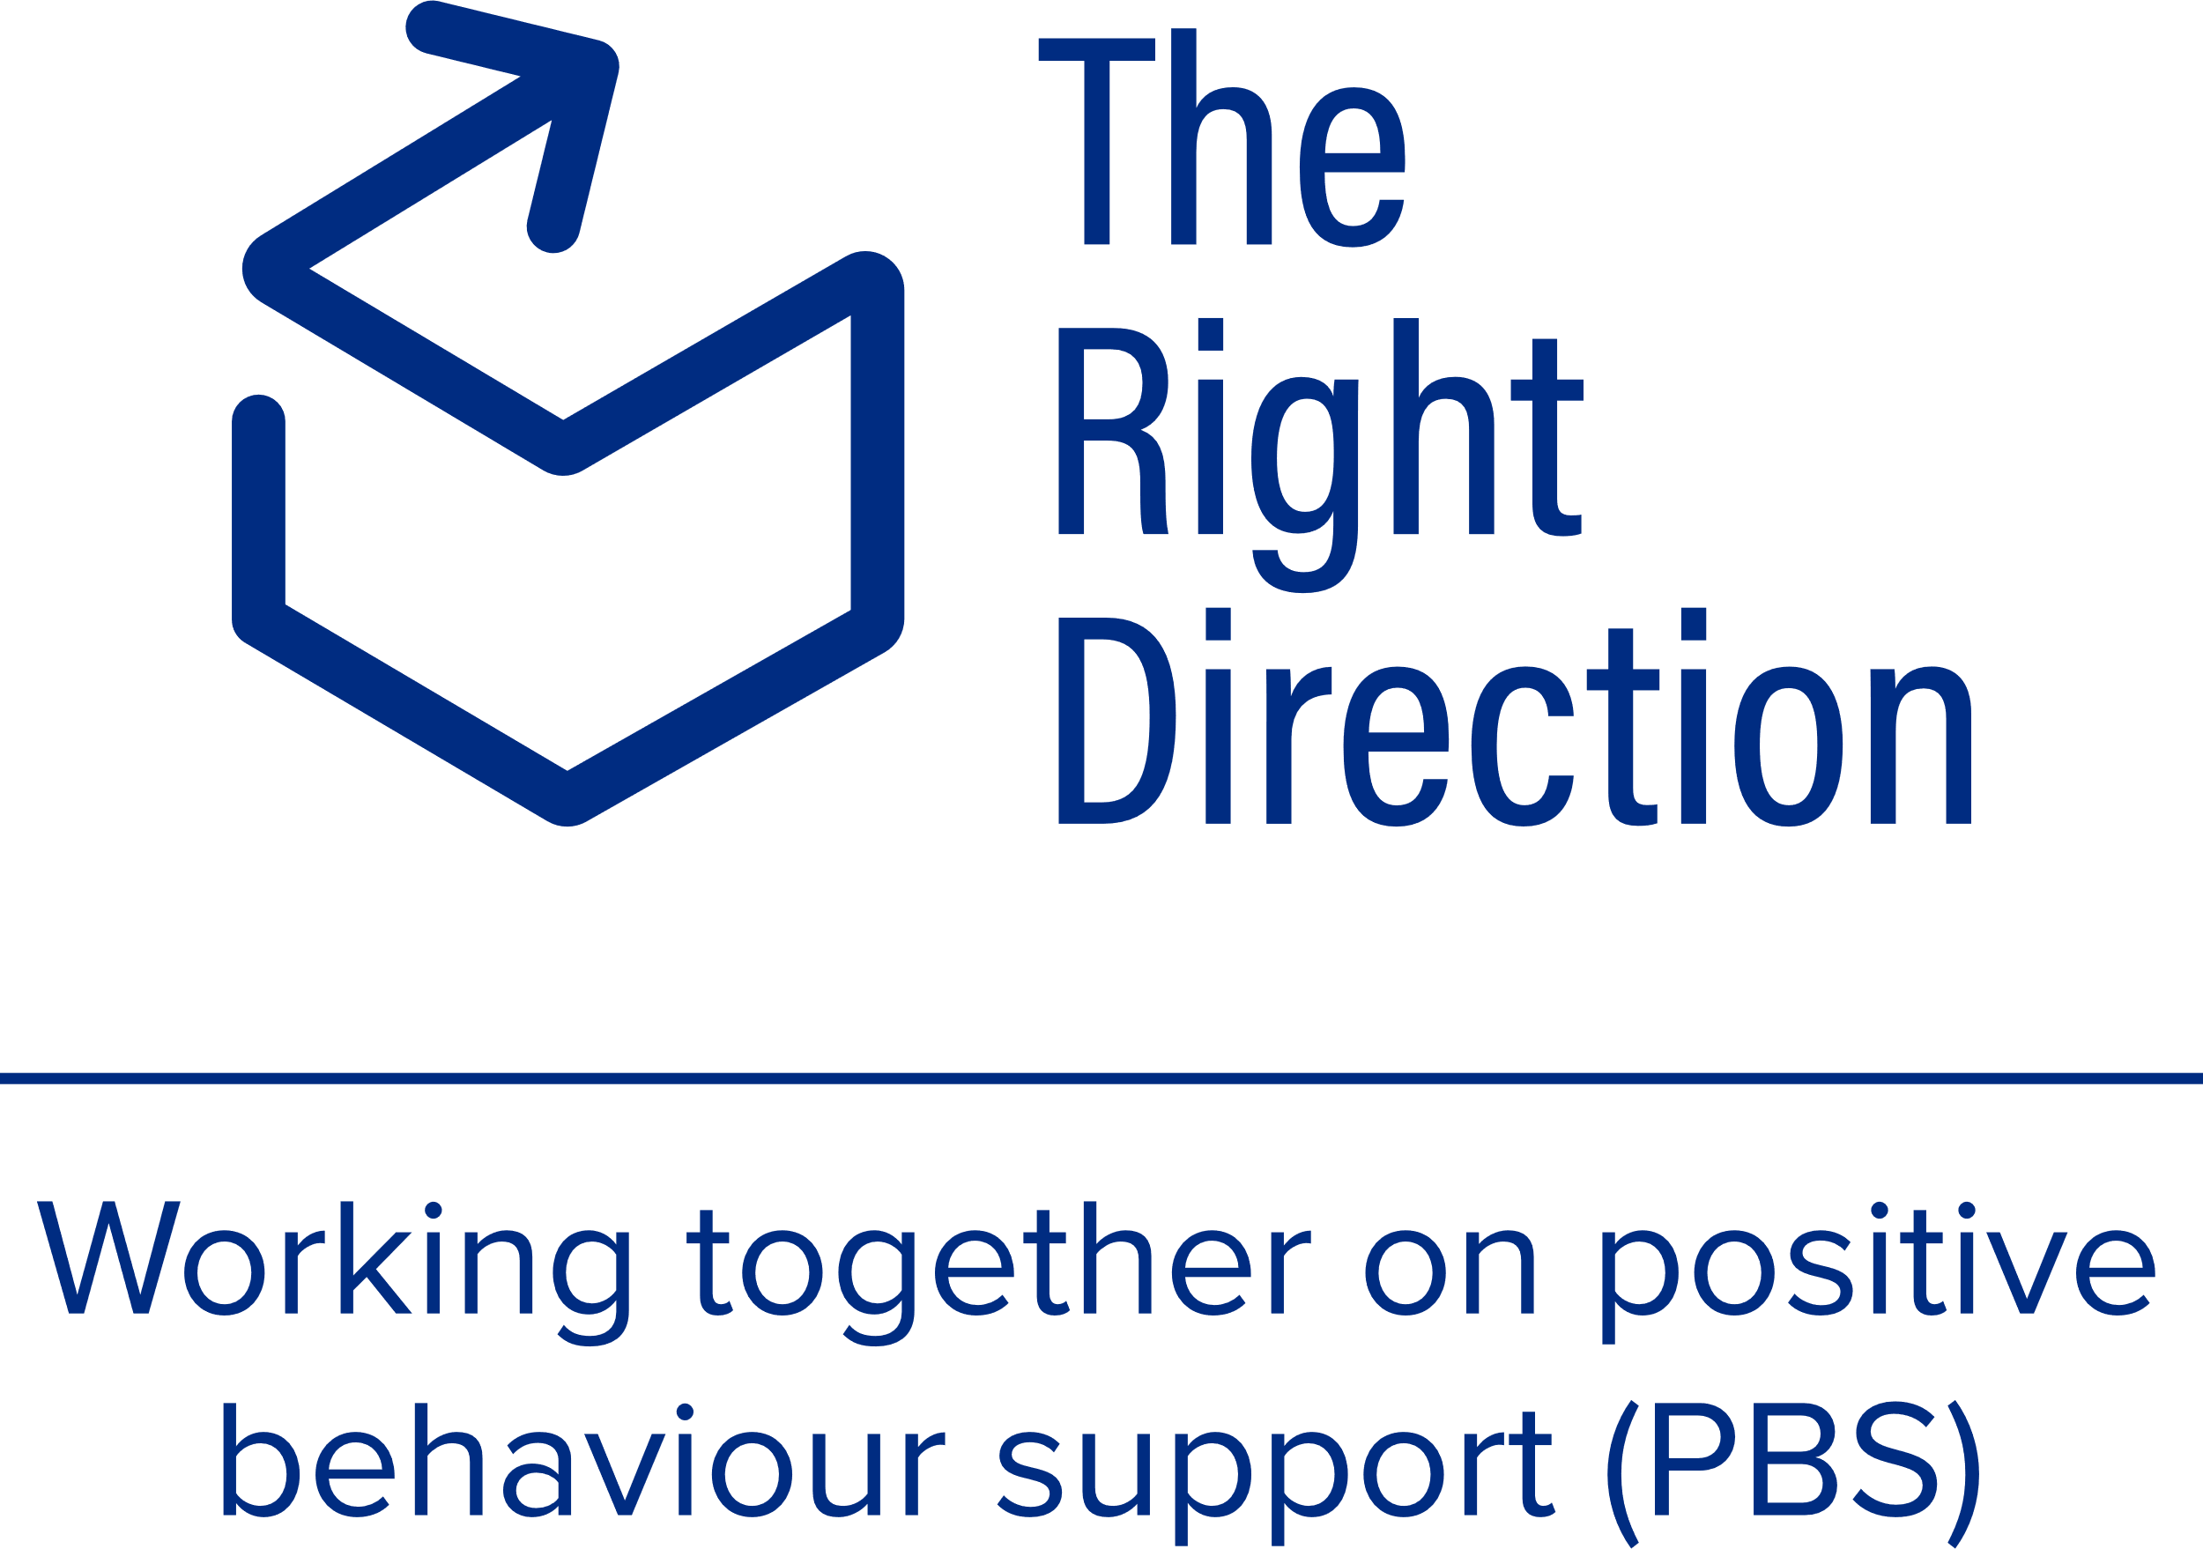

## Building trust and rapport: An essential step

As a behaviour support practitioner, building trust is a central part of ensuring a successful behaviour support process, where participants feel able to ask questions, ask for information, offer ideas and say ‘no’ – all of which uphold [their rights in communicating about their behaviour support](https://therightdirectionpbs.com/resources/communication-rights).

It's important to remember that getting to know someone is a 2-way process. You can find out more about establishing trust through [practices such as yarning](https://therightdirectionpbs.com/resources/yarning) and, when the time is right, progress to using The Right Direction resources designed to help you get to know each other, including these editable conversation cards, and:

* [Getting to know each other: About me (A3)](https://therightdirectionpbs.com/downloads/getting-to-know-each-other/getting_to_know_each_other_about_me_A3.pdf),
* [Getting to know each other: About us (A3)](https://therightdirectionpbs.com/downloads/getting-to-know-each-other/getting_to_know_each_other_about_us_A3.pdf), and
* [Getting to know each other: Conversation cards (A4)](https://therightdirectionpbs.com/downloads/getting-to-know-each-other/getting_to_know_each_other_conversation_cards_A4.pdf).

This will help you build the foundation you need to have the open, supportive and productive conversations that underpin positive relationships between yourself, the participant and their support network. You will need these relationships to write a practical and effective behaviour support plan that genuinely improves quality of life.

This rapport also equips you to [have the difficult conversations](https://therightdirectionpbs.com/resources/having-difficult-conversations) that can be required as part of the behaviour support planning and implementation process.

## Instructions for practitioners

This set of conversation cards are intended to be used by behaviour support practitioners as a tool to use with participants to get to know each other. We encourage you to share information about yourself, as well as asking the participant to open up about themselves.

You can customise these cards with images of your own, if you have some available that are specific to the participant’s life and situation.

You may even wish to enter some information you already know, to show you have been listening and work together to ensure it’s correct and build on it.

You can write words, draw images or insert photos in the conversation cards, either before or after printing.

Of note, the card relating to ‘I don’t want you to know this’ can be used to note down any difficult topics that the people involved don’t want to talk about. Noting down these shows that you have listened and respected each other’s decision and gives you both a reminder for your later visits.

## My name is:

## This is a photo of me:

## The things I like to do (e.g. hobbies, interests)

## The things I look forward to are...

## The things I like about myself are...

## Where I live...

## What does a good day look like for me...

## What does a bad day look like for me...

## I don’t want you to know this:

## Other things I want you to know about me are:



**therightdirectionpbs.com**

Published in 2025