My communication rights



## Customisable conversation cards for behaviour support practitioners to use with participants

The right direction logo - Working together on positive behaviour support (PBS).


## Instructions for behaviour support practitioners

These cards can be used together with the [My communication rights poster](https://therightdirectionpbs.com/downloads/communication-rights/my_communication_rights_poster.pdf) to facilitate a more focused discussion of each of the participant’s key communication rights in the behaviour support panning process.

Some behaviour support practitioners may wish to print these out and use the template for drawing, writing key words or populating with images or photos that are meaningful to each participant.

During your discussion, you might consider linking each of these rights to real-life examples from the participant’s own life or current behaviour support plan to illustrate each right through meaningful context.

If you do not have access to suitable photos or images that relate to the participant, you can use the [communication rights conversation cards with pre-populated images](https://therightdirectionpbs.com/downloads/communication-rights/my_communication_rights_conversation_cards.docx) to support your discussion.

We encourage you to leave a copy of the [My communication rights poster](https://therightdirectionpbs.com/downloads/communication-rights/my_communication_rights_poster.pdf) with the participant and anyone else involved in the plan to remind them of these rights and support understanding after your conversation.

You may also wish to refer to the information and video about [communication rights in behaviour support planning](https://therightdirectionpbs.com/resources/communication-rights) on our website.

## I have the right to…

Insert a picture in this box

(delete this text box before printing as it will show)

be listened to

## I have the right to…

Insert a picture in this box

have my choices heard, respected and considered

I have the right to…I have the right to…I have the right to…I have the right to…I have the right to…I have the right to…I have the right to…I have the right to…I have the right to…I have the right to…

Insert a picture in this box

express my feelings and needs

Insert a picture in this box

say ‘no’

Insert a picture in this box

learn how my behaviour support plan will improve   
my life

ask questions about what is happening and why

Insert a picture in this box

learn about how others will keep me safe

Insert a picture in this box

Insert a picture in this box

ask for information   
I can understand

be part of making my behaviour support plan

Insert a picture in this box

have information about behaviour support planning

Insert a picture in this box

information to help me take part in making my behaviour support plan

Insert a picture in this box

Insert a picture in this box

be spoken to and about with respect



**therightdirectionpbs.com**

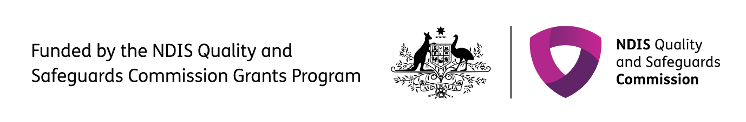The right direction logo - Working together on positive behaviour support (PBS).


Published in 2025