My communication rights



## Conversation cards for behaviour support practitioners to use with participants

The right direction logo - Working together on positive behaviour support (PBS).


## Instructions for behaviour support practitioners

These cards can be used together with the [My communication rights poster](https://therightdirectionpbs.com/downloads/communication-rights/my_communication_rights_poster.pdf) to facilitate a more focused discussion of each of the participant’s key communication rights in the behaviour support panning process.

Some behaviour support practitioners may wish to print these out, laminate them and link them together with a loop so they can be easily flicked through as you progress through your discussion.

You might consider linking each of these rights to real-life examples from the participant’s own life or current behaviour support plan to illustrate each right through meaningful context.

If you have photos or images that relate to the participant, you can use the [customisable conversation card template](https://therightdirectionpbs.com/downloads/communication-rights/my_communication_rights_conversation_cards_customisable.docx) to support your discussion.

We encourage you to leave a copy of the [My communication rights poster](https://therightdirectionpbs.com/downloads/communication-rights/my_communication_rights_poster.pdf) with the participant and anyone else involved in the plan to remind them of these rights and support understanding after your conversation.

You may also wish to refer to the information and video about [communication rights in behaviour support planning](https://therightdirectionpbs.com/resources/communication-rights) on our website.

## An image of an ear with the text below that says "Be listened to"I have the right to…

be listened to

## I have the right to…

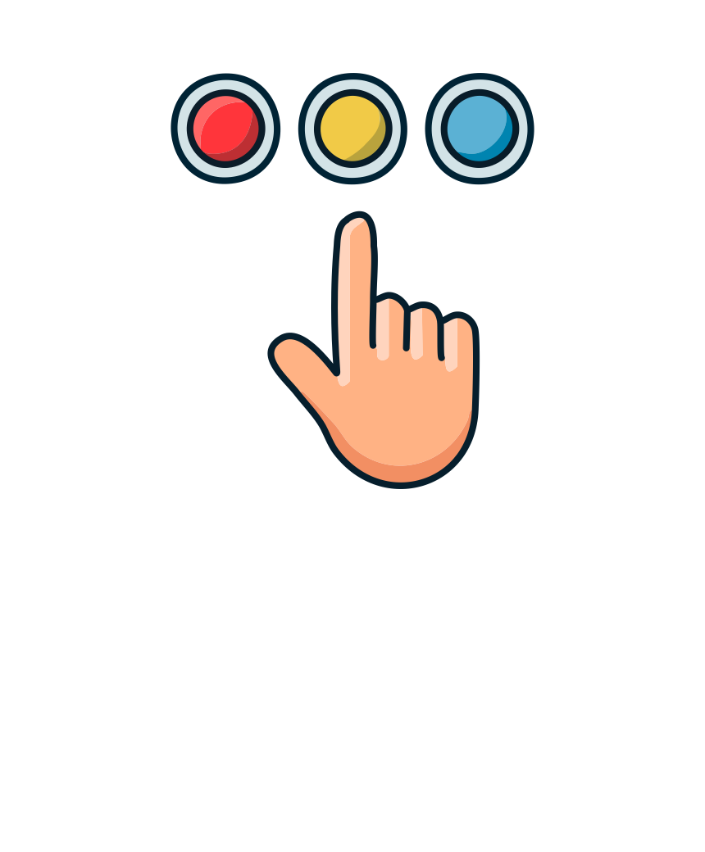

have my choices heard, respected and considered

I have the right to…I have the right to…I have the right to…I have the right to…I have the right to…I have the right to…I have the right to…I have the right to…I have the right to…I have the right to…



express my feelings and needs



say ‘no’

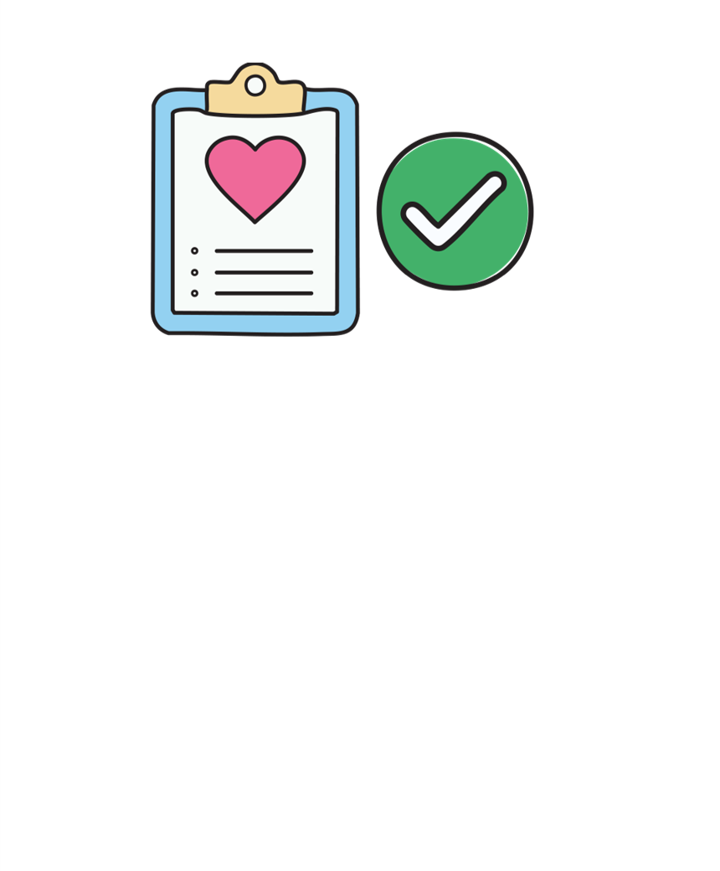

learn how my behaviour support plan will improve   
my life

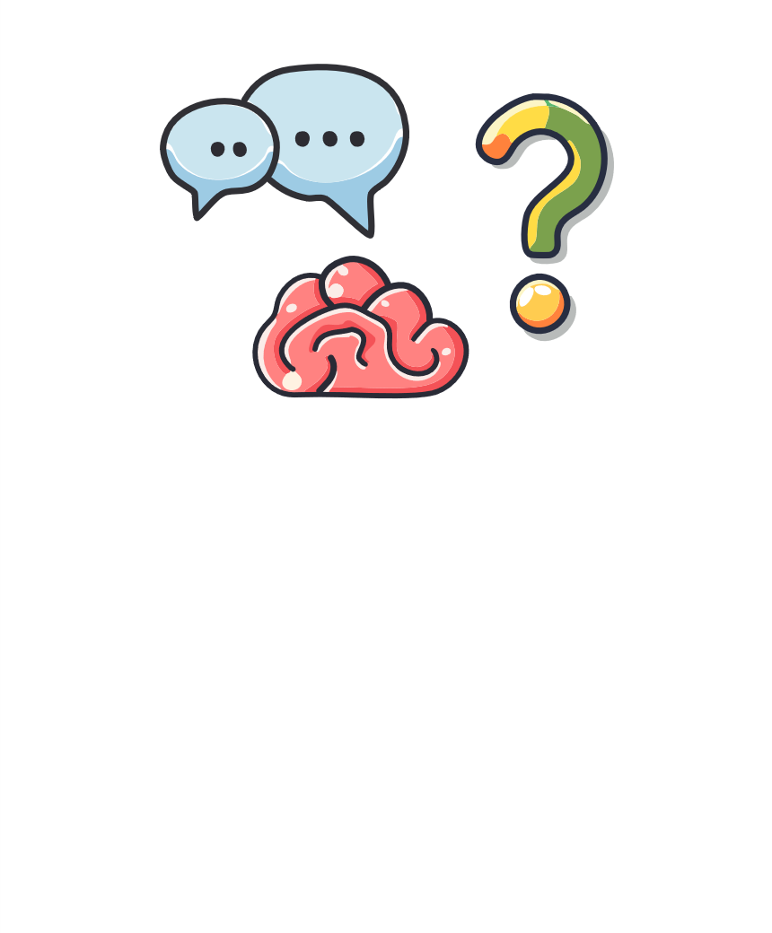

ask questions about what is happening and why

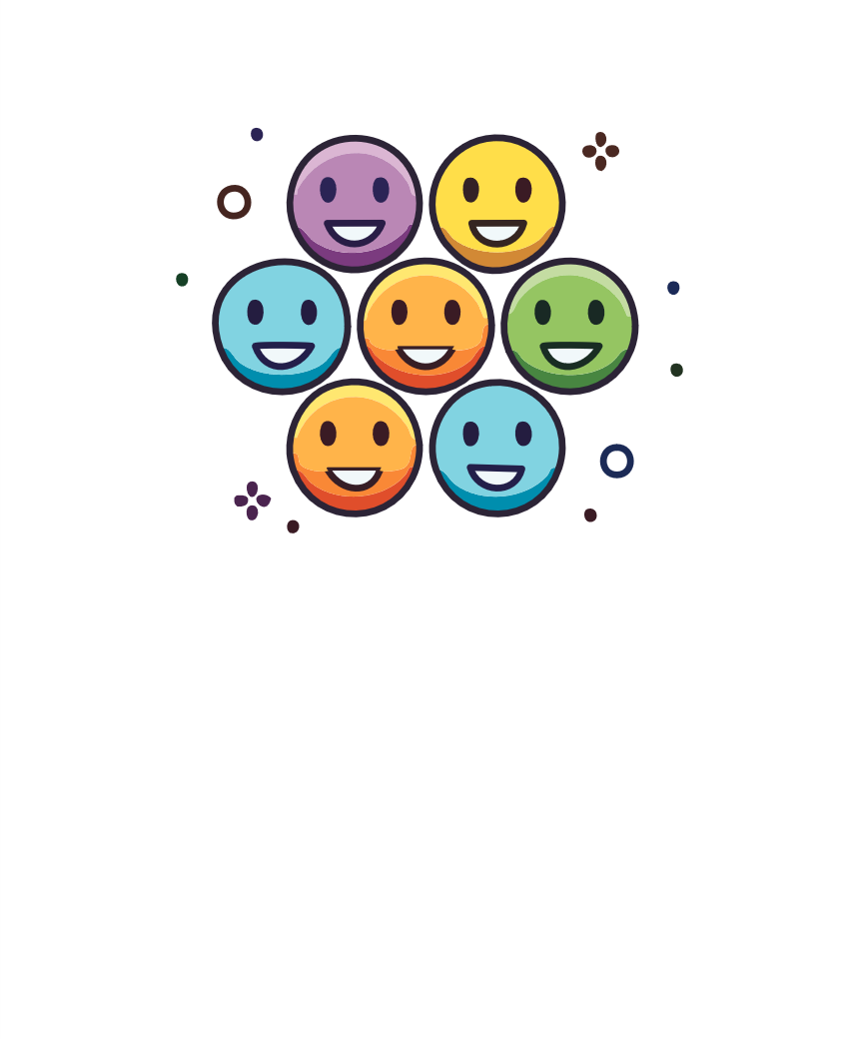

learn about how others will keep me safe

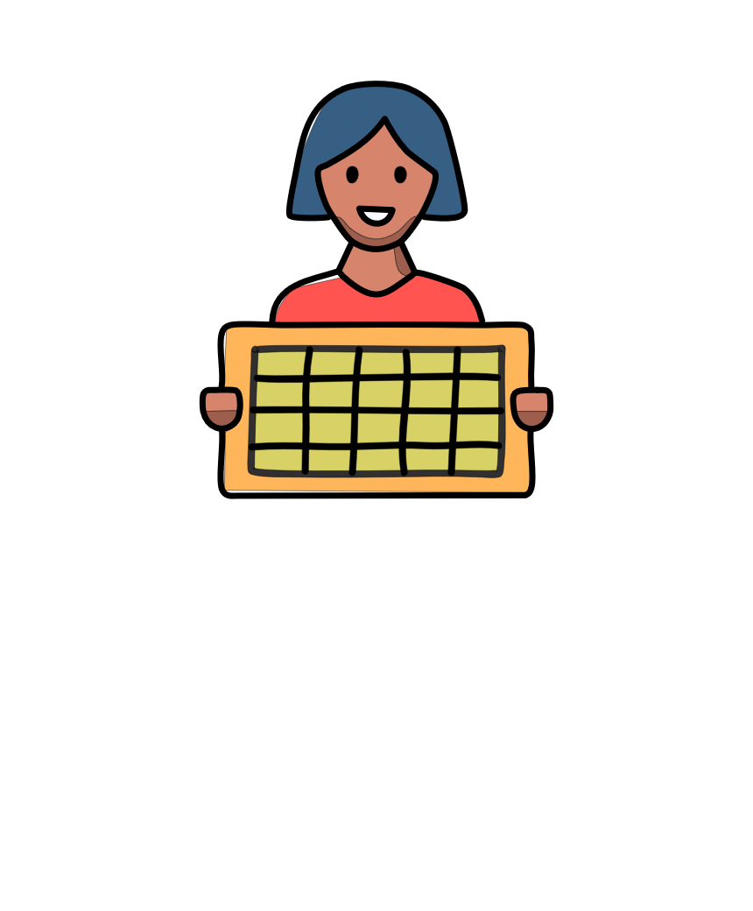

ask for information   
I can understand

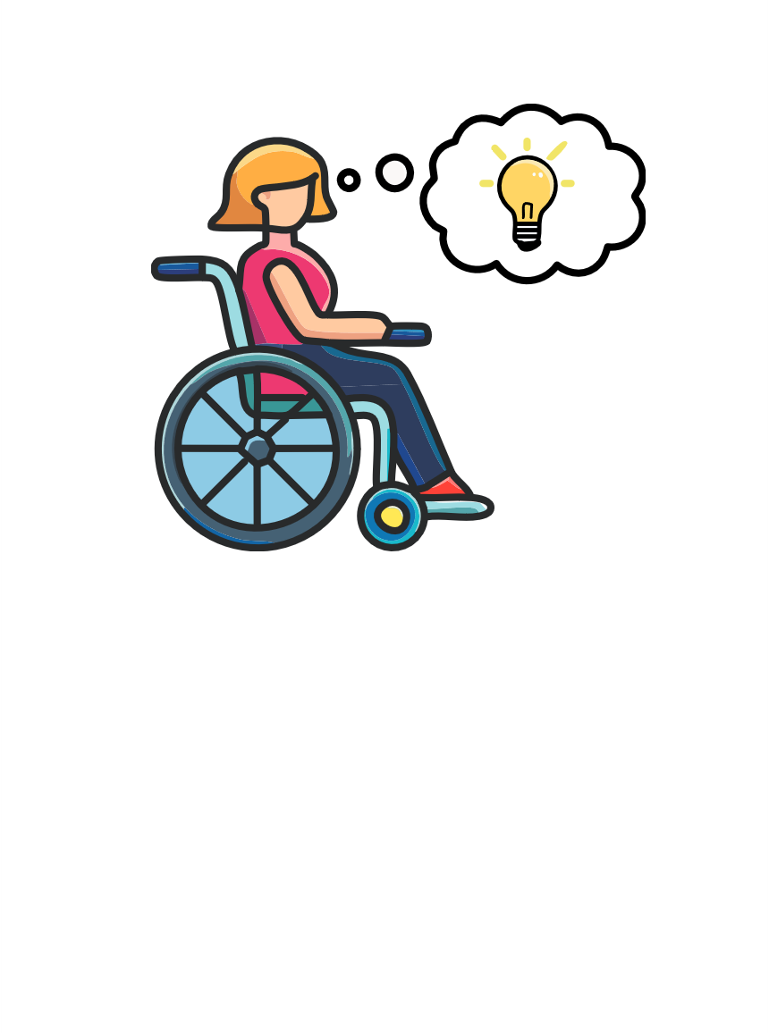

be part of making my behaviour support plan

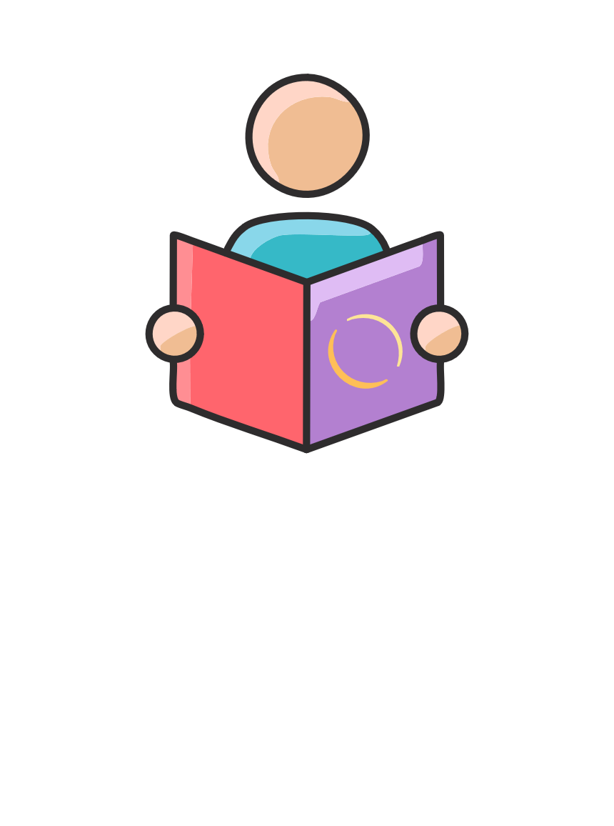

have information about behaviour support planning



information to help me take part in making my behaviour support plan

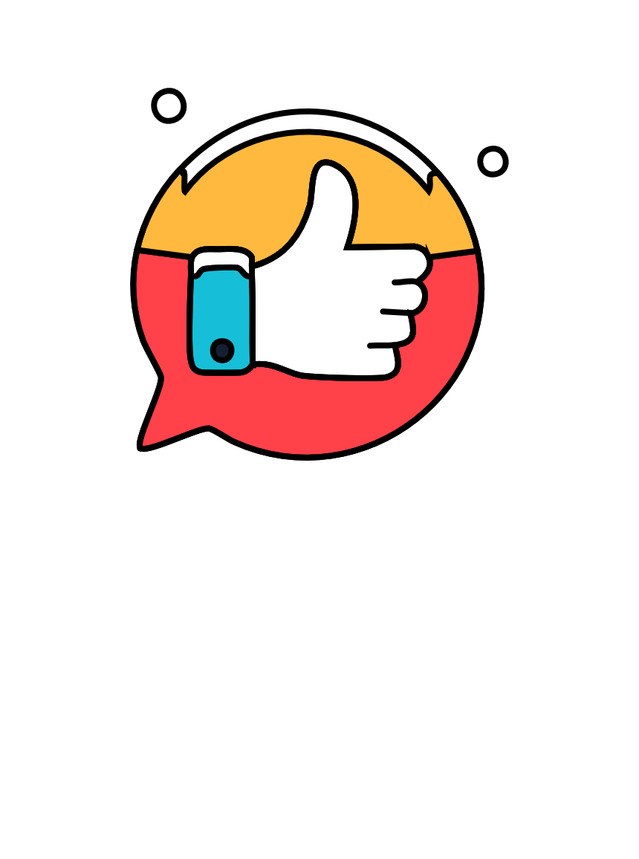

be spoken to and about with respect



**therightdirectionpbs.com**

Funded by the NDIS Quality and safeguards Commission Grants Program.
The right direction logo - Working together on positive behaviour support (PBS).


Published in 2025