Communicating about behaviours of concern



## Example discussion mat

The right direction logo - Working together on positive behaviour support (PBS).


## Instructions for behaviour support practitioners

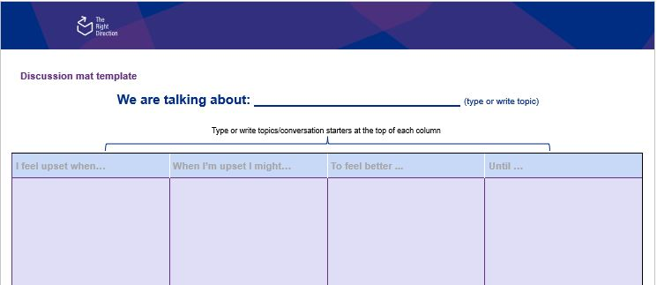This is an example discussion mat for behaviour support practitioners to use when talking about behaviours of concern. It includes some strategies that can be useful during the behaviour support planning process.

You can use it either for your own information or as a tool to use with behaviour support participants. You can use this example mat it aligns with the needs of the participant’s needs or customise it to suit the individual needs of each participant.

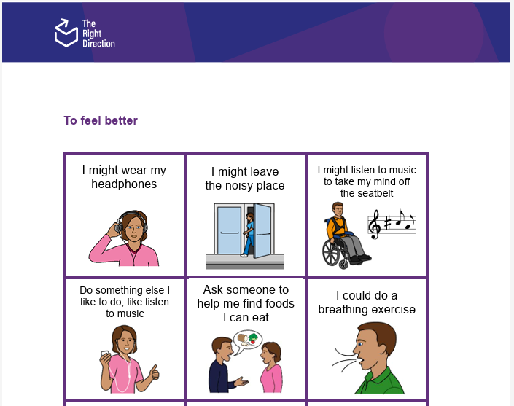This Word document is editable to allow you to change it as you need. [The Right Direction website](https://therightdirectionpbs.com/) also provides an editable [Word-based discussion mat and picture card template](https://therightdirectionpbs.com/downloads/using-discussion-mats/different_communication_techniques_discussion_mat_and_picture_cards_template_A3.docx) for you to make your own mat, and word, picture or photo-based cards according to your needs and uses.

PCS is a trademark of Tobii Dynavox, LLC. All rights reserved. Used with permission.

[Download the discussion mat template](https://therightdirectionpbs.com/downloads/using-discussion-mats/different_communication_techniques_discussion_mat_and_picture_cards_template_A3.docx)

For this example discussion mat about behaviours of concern, you can also download and print [matching picture cards (A4)](https://therightdirectionpbs.com/downloads/behaviours-of-concern/behaviours_of_concern_picture_cards_A4.pdf) and [larger matching picture cards (A4)](https://therightdirectionpbs.com/downloads/behaviours-of-concern/behaviours_of_concern_large_picture_cards_A4.pdf), if needed.

If your behaviour support planning process includes a need to discuss restrictive practices, you can find an [example mat for discussing restrictive practices](https://therightdirectionpbs.com/downloads/restrictive-practices/restrictive_practices_example_discussion_mat_A3.docx), with [matching picture cards (A4)](https://therightdirectionpbs.com/downloads/restrictive-practices/restrictive_practices_picture_cards_A4.pdf) and [larger matching picture cards (A4)](https://therightdirectionpbs.com/downloads/restrictive-practices/restrictive_practices_large_picture_cards_A4.pdf).

You can also watch The Right Direction videos on [communicating about restrictive practices (overview)](https://therightdirectionpbs.com/resources/restrictive-practices#video) and [communicating about restrictive practices: advice from peers](https://therightdirectionpbs.com/resources/restrictive-practices).

Behaviours of concern [matching picture cards (A4)](https://therightdirectionpbs.com/downloads/behaviours-of-concern/behaviours_of_concern_picture_cards_A4.pdf)   
and [larger matching picture cards (A4)](https://therightdirectionpbs.com/downloads/behaviours-of-concern/behaviours_of_concern_large_picture_cards_A4.pdf)

### Stage 1: Working together on behaviours of concern (example discussion mat)

|  |  |  |  |
| --- | --- | --- | --- |
| I feel upset when ... | When I’m upset I might ... | To feel better ... | Until … |
| e.g., There’s too much noise | e.g., Hit myself | e.g., I might wear my headphones  e.g., I might leave the noisy place | e.g., I feel calm / I say that I feel calm |
| e.g., I have to wear a seatbelt | e.g., Take off my seatbelt | e.g., I might listen to music to take my mind off the seatbelt | e.g., Until we get home / the car stops |
| e.g., It’s time to stop using my iPad | e.g., I throw or break my iPad | e.g., Do something else I like to do, like listen to music | e.g., I feel calm / I say that I feel calm |
| e.g., I am not allowed to eat chips because of my special diet | e.g., Take chips from the cupboard | e.g., Ask someone to help me find foods I can eat | e.g., I find the food I can eat |
| e.g., People come into my room without asking if it’s okay to come in | e.g., Hit people | e.g., I could do a breathing exercise | e.g., I am not upset anymore |
| e.g., I am in a crowd | e.g., Push people | e.g., Move away to a quiet place | e.g., I feel calm |
| e.g., My routine is changed without telling me | e.g., Yell | e.g., I could use my sensory toys | e.g., I am not upset anymore |



Funded by the NDIS Quality and safeguards Commission Grants Program.
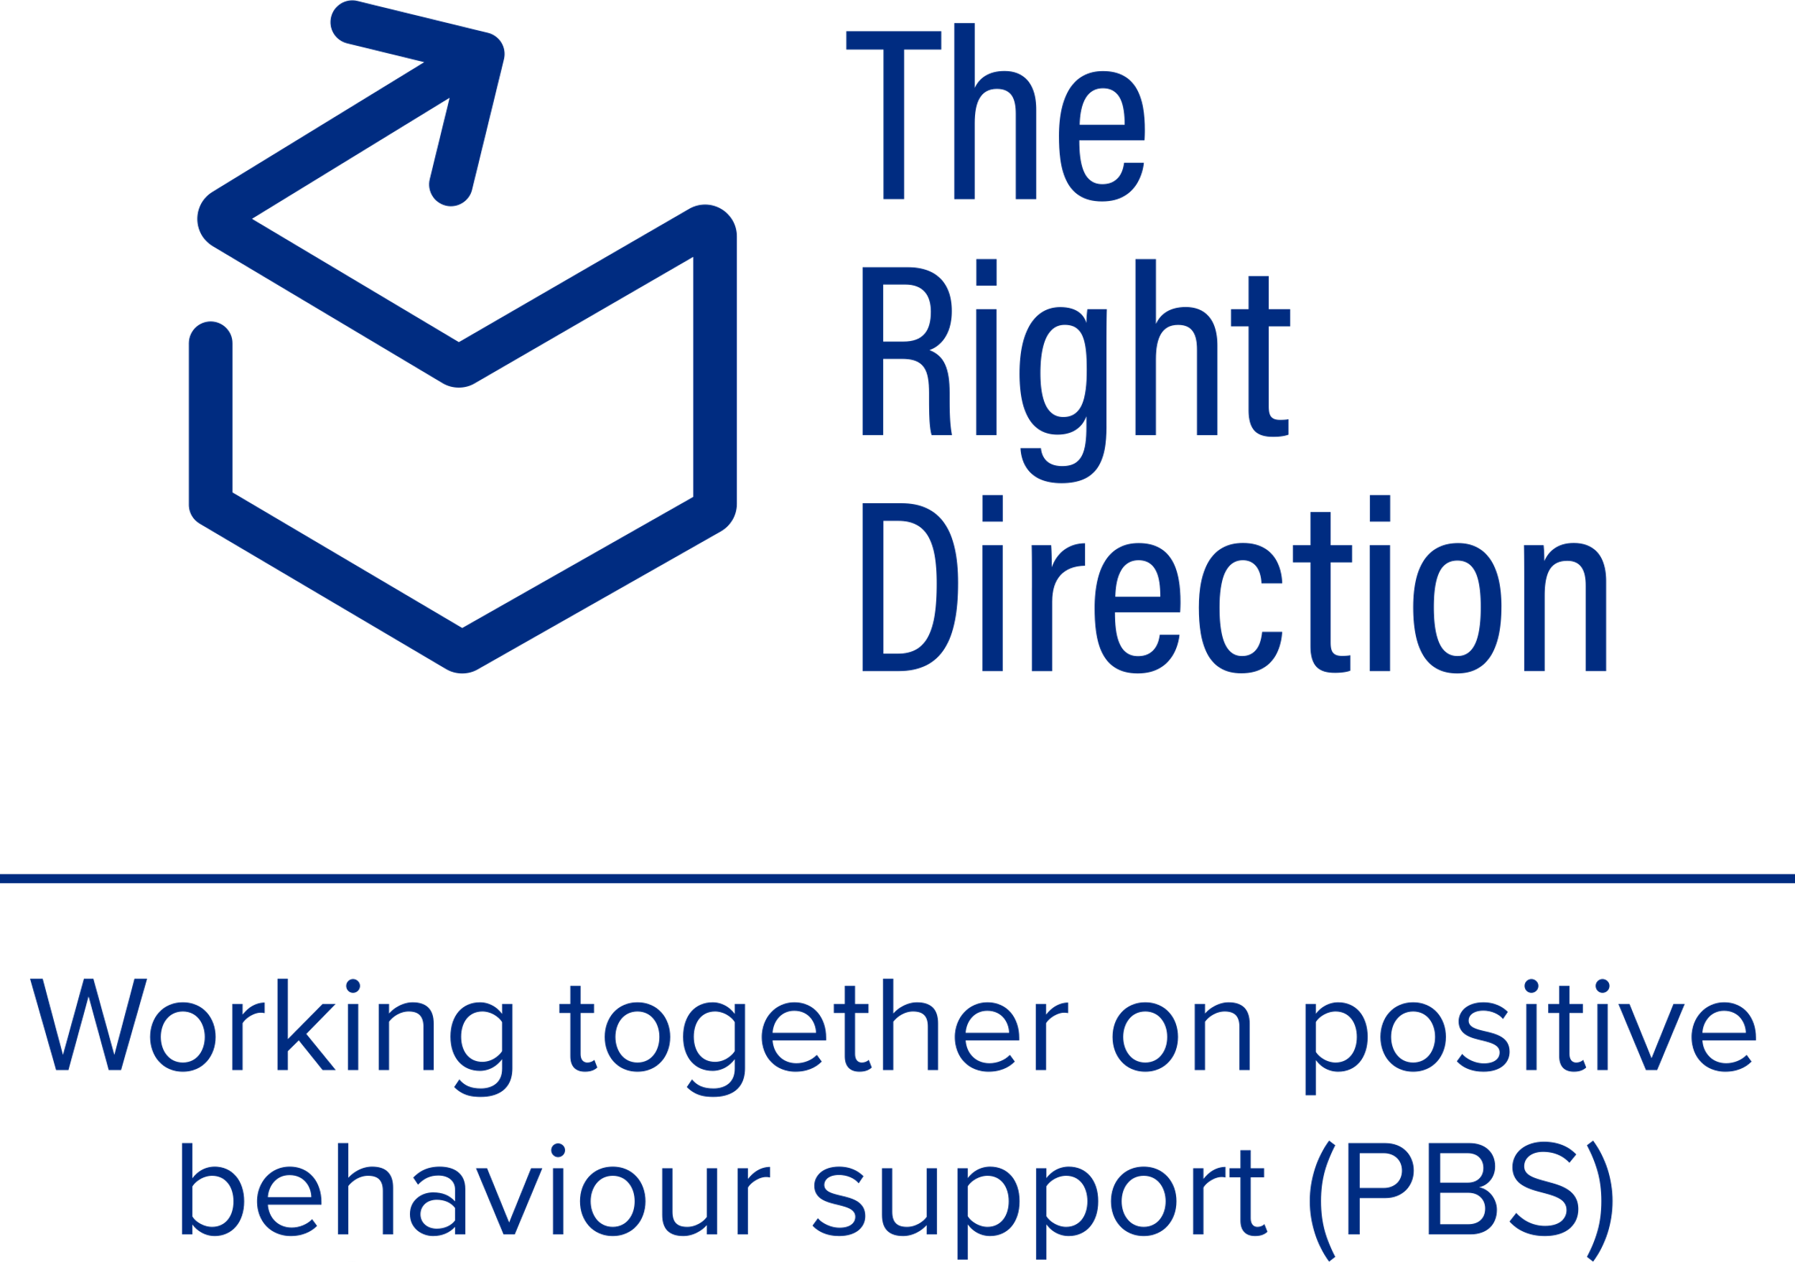

Published in 2025

**therightdirectionpbs.com**