Talking about behaviour support and the planning process



## A guide to communication and resources for engaging with behaviour support participants and their support networks

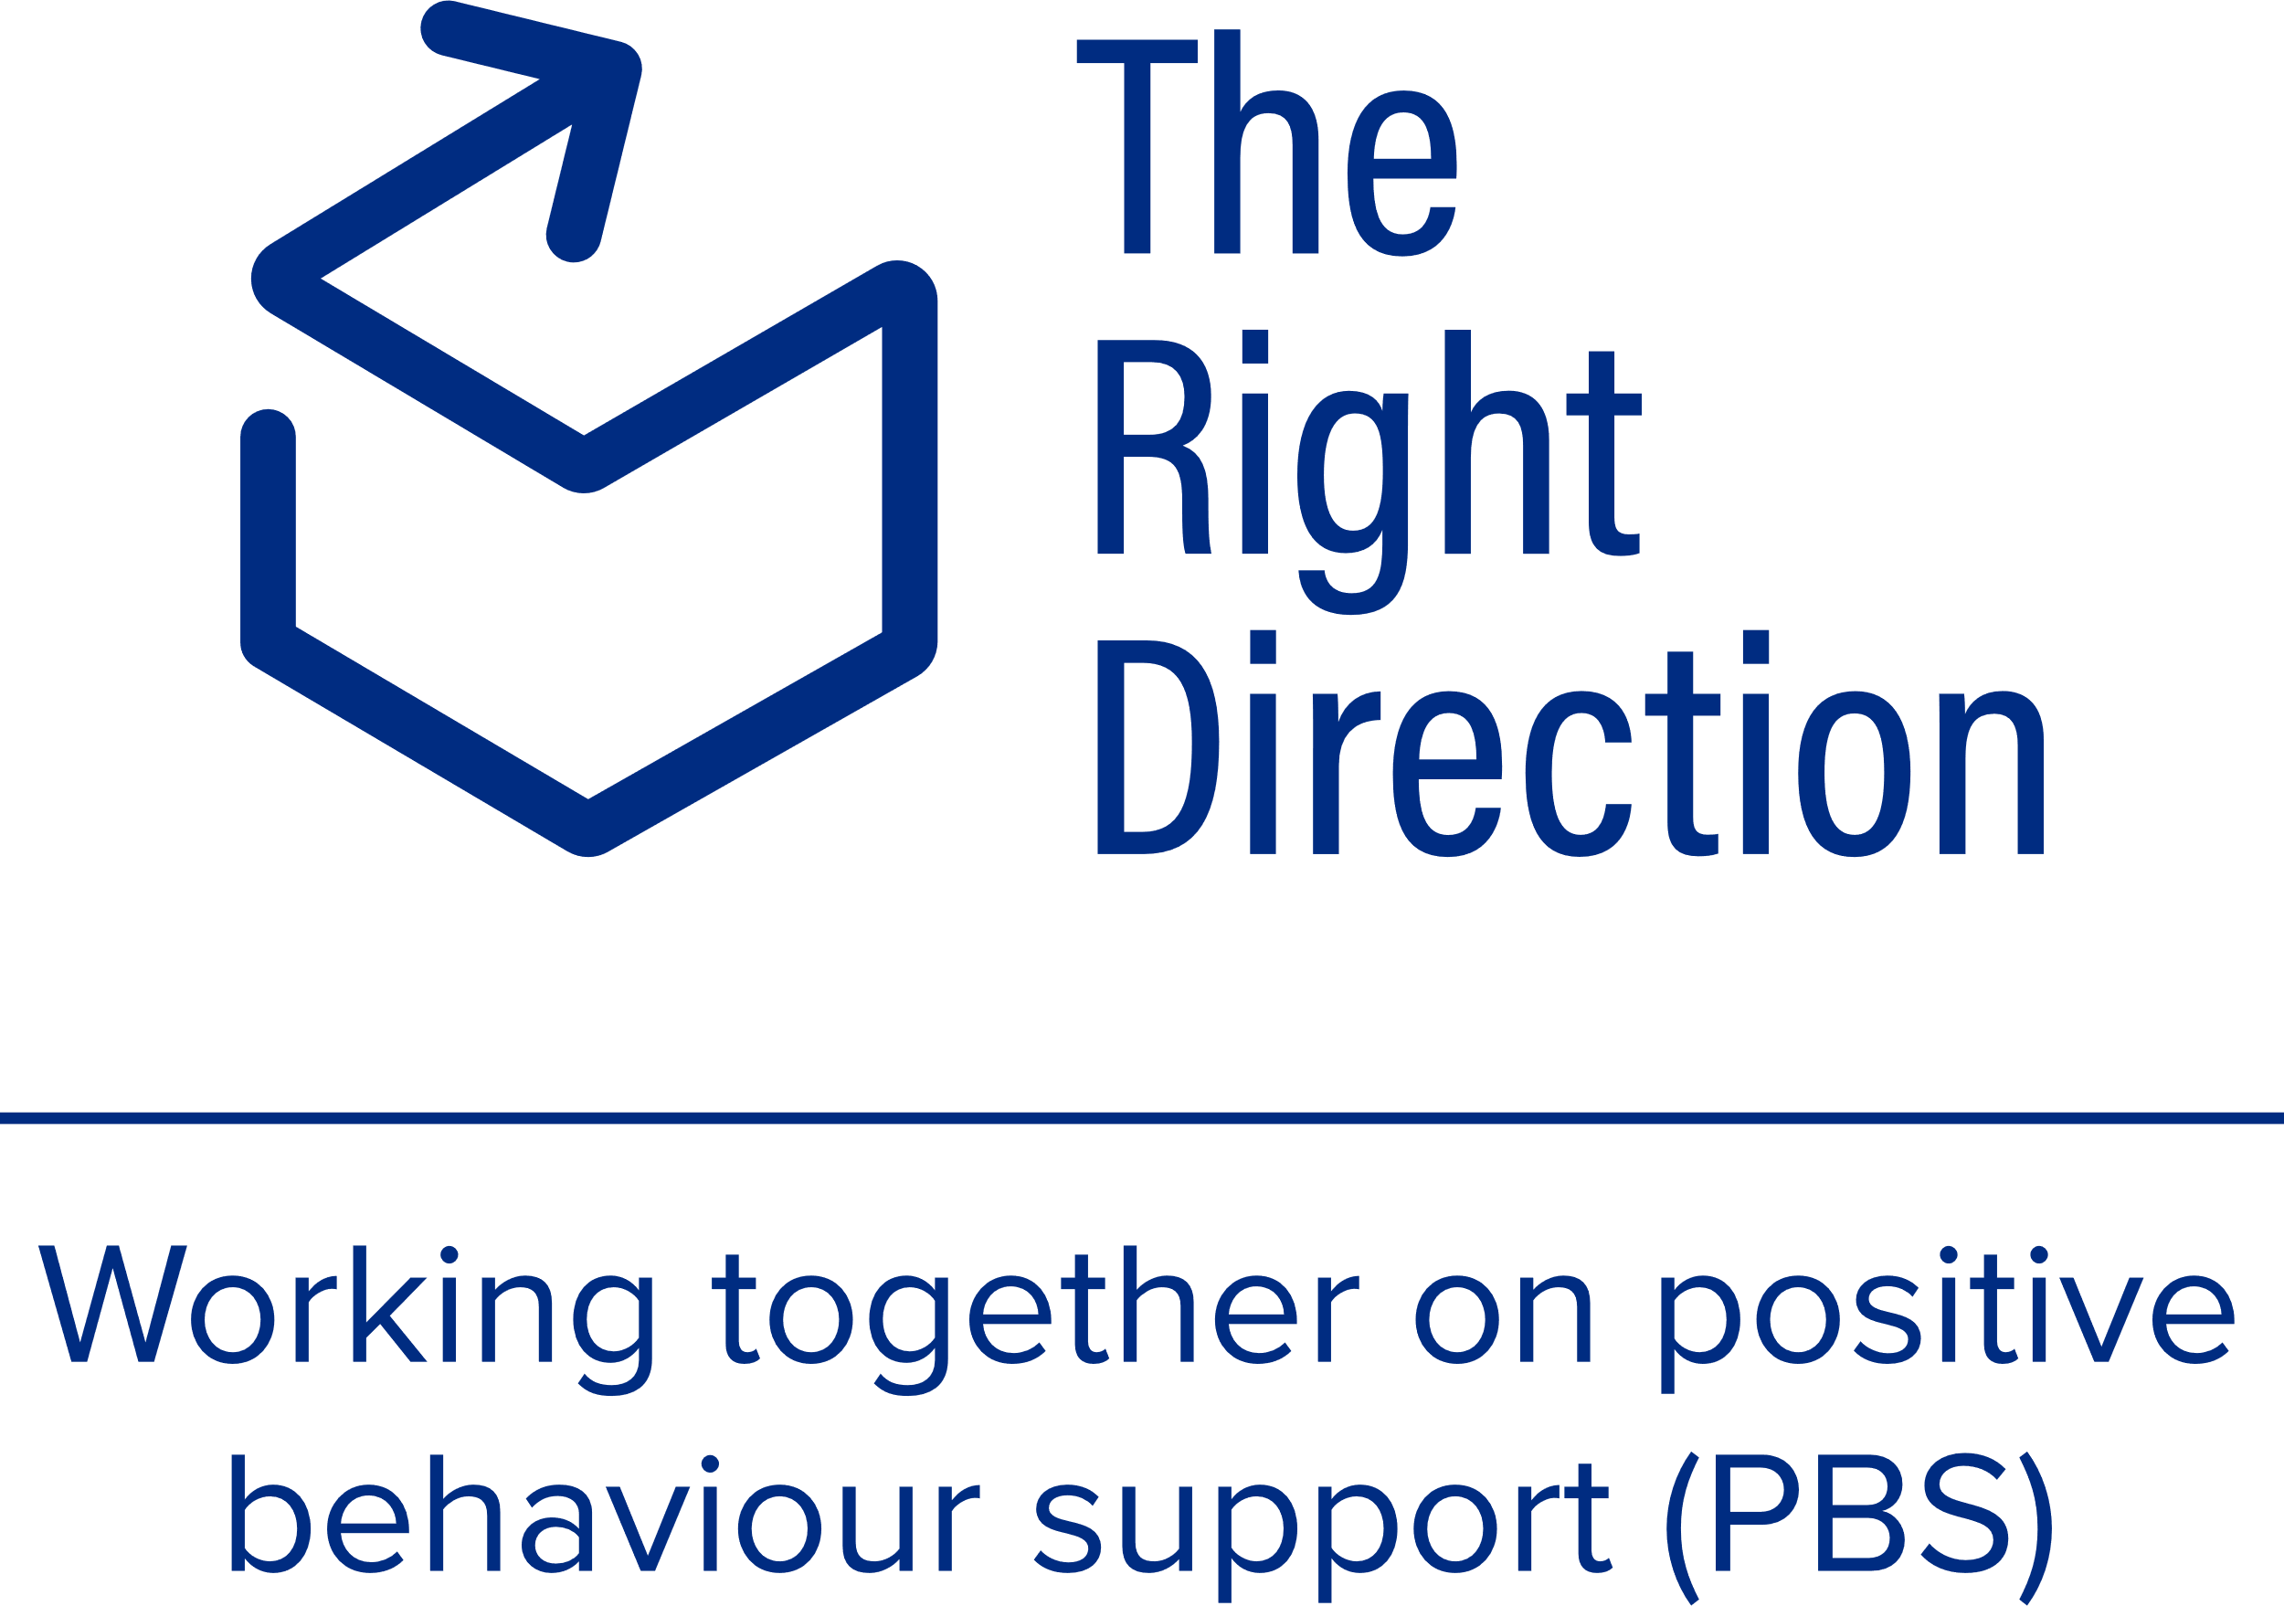

## Instructions for behaviour support practitioners

The information in this document does not aim to teach the clinical practice of behaviour support, but instead focuses on consolidating the principles of communication and engagement available through [The Right Direction](https://therightdirectionpbs.com/) to help you engage with people throughout the process.

It’s important to remember as a behaviour support practitioner that participants and their support networks may not know (or remember) who you are and what you do.

Behaviour support planning and implementation is a process that involves a lot of people and is a process that takes place over a long period of time. It can be difficult to find the best way to communicate about what behaviour support planning is and how the process works.

Making sure participants and their support networks feel confident they understand why you’re there and how you’re going to help is central to upholding [the participant’s communication rights](https://therightdirectionpbs.com/resources/communication-rights) and underpins the trust required for successful behaviour support planning.

## Explaining what’s involved

The [NDIS Quality and Safeguards Commission](https://www.ndiscommission.gov.au/) already provides information about behaviour support that can be helpful in terms of some language and information that helps you explain what’s involved.

* [What do we mean by behaviour support?](https://ourguidelines.ndis.gov.au/supports-you-can-access-menu/behaviour-support/what-do-we-mean-behaviour-support)
* [What’s a behaviour assessment?](http://ourguidelines.ndis.gov.au/supports-you-can-access-menu/behaviour-support/whats-behaviour-assessment)
* [What’s a behaviour support plan?](https://ourguidelines.ndis.gov.au/supports-you-can-access-menu/behaviour-support/whats-behaviour-support-plan)
* [What if you need behaviour support in your plan?](https://ourguidelines.ndis.gov.au/supports-you-can-access-menu/behaviour-support/what-if-you-need-behaviour-support-your-plan)

### How do I communicate this information to engage effectively?

As a behaviour support practitioner, you will communicate with a variety of people as part of the behaviour support planning process.

It is critical that the participant and the people closest to them understand what this process is, why it’s important and what will happen during the process, as well as once the plan is in place.

People need to know their rights. People need to know their options and the choices they can make. People need to know what they can expect of you as a practitioner; what you will do and how you will behave when working with them.

This is fundamental to upholding [the participant’s communication rights](https://therightdirectionpbs.com/resources/communication-rights) during the behaviour support process and also central to ethical, effective behaviour support planning.

Some key issues you’ll need effective communication for include:

* Formulating a plan for understanding who you need to engage as part of the process, including who you need to speak with and what you need to know from meeting with them.
* Gaining background information to familiarise yourself with the participant, their needs and their situation by reading what’s already available via reports or discussions with other key people.
* Understanding how best to use this information, including the boundaries of privacy and confidentiality.
* Navigating how gathering all this information informs the behaviour support plan in a way that will benefit the person and improve their quality of life.
* Consideration and planning for: :
  + how the participant communicates best,
  + signs the participant may not understand what you’re saying,
  + how to adjust the conversation to better meet their communication support needs, and
  + how to build and maintain trust.

Prepare yourself to switch communication tactics based on cues from the participant and anyone else involved in the discussion.

### Embedding new routines

One of the biggest challenges you may face in behaviour support planning is establishing new routines and getting people to follow the changes required as part of the behaviour support plan.

You may wish to familiarise yourself with the following resources about effectively changing behaviour:

* [Building and maintaining a team](https://therightdirectionpbs.com/resources/building-and-maintaining-a-team)
* [Engaging others in change (video)](https://therightdirectionpbs.com/resources/support-networks-and-change#video)
* [Engaging support networks in change](https://therightdirectionpbs.com/resources/support-networks-and-change)
* [Preparing for and conducting assessments](https://therightdirectionpbs.com/resources/preparing-and-conducting-behaviour-support-planning)

### Communicating in plain language

Familiarise yourself with vocabulary or key phrases that might be helpful in the discussion, considering the participant and their support network’s communication needs.

When preparing, consider:

* the nature of the participant’s disability in terms of understanding and communication style, needs and preferences,
* people’s culture,
* people’s first language,
* people’s English language knowledge, fluency and literacy,
* previous experiences with the behaviour support process (including the possibility they may have had negative experiences previously and how you will support them through this – adopting a trauma-informed approach)

**Write down the best way to provide the participant’s support plan.**

To the participant: ___________________________________________

To their support network? _____________________________________

Who will support the participant understand and engage with the information? _______________________________________________

### Visual tools and supports to improve engagement

You might consider several tools to use with participants to help improve engagement.

**Explaining behaviour support planning**

* [My communication rights in behaviour support planning (poster)](https://therightdirectionpbs.com/downloads/communication-rights/my_communication_rights_poster.pdf)
* [My communication rights: Conversation cards](https://therightdirectionpbs.com/downloads/communication-rights/my_communication_rights_conversation_cards.docx)
* [My communication rights: Conversation cards (customisable)](https://therightdirectionpbs.com/downloads/communication-rights/my_communication_rights_conversation_cards_customisable.docx)
* [Spectrum of Participation (Easy Read)](https://therightdirectionpbs.com/downloads/spectrum-of-participation/spectrum_of_participation_easy_read.docx)
* [Spectrum of Participation: Working together tool (customisable)](https://therightdirectionpbs.com/downloads/spectrum-of-participation/spectrum_of_participation_working_together_tool.docx)

You can also employ the following resources to support you as a behaviour support practitioner to use the above tools effectively:

* The need: Moving in The Right Direction (video)  
  You may choose to watch this with participants, with the support of  
  [The need: Moving in The Right Direction (video words in plain language)](https://therightdirectionpbs.com/downloads/about-us/moving_in_the_right_direction_video_words_in_plain_language.docx)
* [Communication rights in behaviour support planning (video)](https://therightdirectionpbs.com/resources/communication-rights#video)
* [Understanding communication & engagement (video)](https://therightdirectionpbs.com/resources/understanding-communication-and-engagement#video)

**Communicating effectively**

* [Key Word Sign: Communication rights in behaviour support planning](https://therightdirectionpbs.com/downloads/using-key-word-sign/key_word_sign_communication_rights_in_behaviour_support_planning.pdf)
* [Key Word Sign: Key terms for behaviour support planning](https://therightdirectionpbs.com/downloads/using-key-word-sign/key_word_sign_key_terms_in_behaviour_support_planning.pdf)
* [Using different communication techniques: Discussion mat and picture card template](https://therightdirectionpbs.com/downloads/using-discussion-mats/different_communication_techniques_discussion_mat_and_picture_cards_template_A3.docx)
* [Different communication techniques: Picture cards template (A3)](https://therightdirectionpbs.com/downloads/using-discussion-mats/different_communication_techniques_picture_cards_template_A3.docx)
* [Different communication techniques: Large picture cards template (A4)](https://therightdirectionpbs.com/downloads/using-discussion-mats/different_communication_techniques_large_picture_cards_template_A4.docx)
* [Different communication techniques: Picture cards template (A4)](https://therightdirectionpbs.com/downloads/using-discussion-mats/different_communication_techniques_picture_cards_template_A4.docx)

You can also employ the following resources to support you as a behaviour support practitioner to use the above tools effectively:

* [Talking about behaviour support in ways everyone can understand (video)](https://therightdirectionpbs.com/resources/talking-about-behaviour-support" \l "video)
* [Engaging people in rural, regional & remote locations (video)](https://therightdirectionpbs.com/resources/rural-regional-and-remote" \l "video)
* [Effective behaviour support: Learning from First Nations practice (video)](https://therightdirectionpbs.com/resources/first-nations-practice#video)
* [Different communication techniques: Key Word Sign (video)](https://therightdirectionpbs.com/resources/using-key-word-sign#video)

**Building trust**

* [Getting to know each other: About me (A3)](https://therightdirectionpbs.com/downloads/getting-to-know-each-other/getting_to_know_each_other_about_me_A3.pdf)
* [Getting to know each other: About us (A3)](https://therightdirectionpbs.com/downloads/getting-to-know-each-other/getting_to_know_each_other_about_us_A3.pdf)
* [Getting to know each other: Conversation cards (A4)](https://therightdirectionpbs.com/downloads/getting-to-know-each-other/getting_to_know_each_other_conversation_cards_A4.pdf)
* [Getting to know each other: Customisable conversation cards (A4)](https://therightdirectionpbs.com/downloads/getting-to-know-each-other/getting_to_know_each_other_customisable_conversation_cards_A4.docx)

You can also employ the following video to support you as a behaviour support practitioner in building trust effectively:

* [Applying First Nations’ Yarning: Good practice for everyone (video)](https://therightdirectionpbs.com/resources/yarning#video)

**Involving the right people**

* [Working together as a support network (plain language)](https://therightdirectionpbs.com/downloads/working-together-support-networks/working_together_as_a_support_network_plain_language.docx)
* [Working together as a support network (easy read)](https://therightdirectionpbs.com/downloads/working-together-support-networks/working_together_as_a_support_network_easy_read.docx)
* [What does my support network look like?](https://therightdirectionpbs.com/downloads/your-support-network/what_does_my_support_network_look_like.docx)
* [The Hand of Trust](https://therightdirectionpbs.com/downloads/your-support-network/the_hand_of_trust.docx)
* [My support network (A3 templates)](https://therightdirectionpbs.com/downloads/your-support-network/my_support_network_A3_templates.pdf)

You can also employ the following video to support you as a behaviour support practitioner in working with the people you need to engage for effective behaviour support planning and implementation:

* [Working effectively within support networks (video)](https://therightdirectionpbs.com/resources/support-networks" \l "video)

**Talking about behaviour support planning**

* [Communicating about behaviours of concern: Picture cards template (A4)](https://therightdirectionpbs.com/downloads/behaviours-of-concern/behaviours_of_concern_picture_cards_template_A4.docx)
* [Communicating about behaviours of concern: Large picture cards template (A4)](https://therightdirectionpbs.com/downloads/behaviours-of-concern/behaviours_of_concern_large_picture_cards_template_A4.docx)
* [Communicating about behaviours of concern: Example discussion mat (A3)](https://therightdirectionpbs.com/downloads/behaviours-of-concern/behaviours_of_concern_example_discussion_mat_A3.docx)
* [Communicating about behaviours of concern: Picture cards (A4)](https://therightdirectionpbs.com/downloads/behaviours-of-concern/behaviours_of_concern_large_picture_cards_A4.pdf)
* [Communicating about behaviours of concern: Large picture cards (A4)](https://therightdirectionpbs.com/downloads/behaviours-of-concern/behaviours_of_concern_picture_cards_A4.pdf)
* [Communicating about restrictive practices: Picture cards template (A4)](https://therightdirectionpbs.com/downloads/restrictive-practices/restrictive_practices_picture_cards_template_A4.docx)
* [Communicating about restrictive practices: Large picture cards template (A4)](https://therightdirectionpbs.com/downloads/restrictive-practices/restrictive_practices_large_picture_cards_template_A4.docx)
* [Communicating about restrictive practices: Example discussion mat (A3)](https://therightdirectionpbs.com/downloads/restrictive-practices/restrictive_practices_example_discussion_mat_A3.docx)
* [Communicating about restrictive practices: Large picture cards (A4)](https://therightdirectionpbs.com/downloads/restrictive-practices/restrictive_practices_large_picture_cards_A4.pdf)
* [Communicating about restrictive practices: Picture cards (A4)](https://therightdirectionpbs.com/downloads/restrictive-practices/restrictive_practices_picture_cards_A4.pdf)
* [Using different communication techniques: Discussion mat and picture card template](https://therightdirectionpbs.com/downloads/using-discussion-mats/different_communication_techniques_discussion_mat_and_picture_cards_template_A3.docx)

You can also employ the following resources to support you as a behaviour support practitioner to use the above tools effectively:

* [Communicating about behaviours of concern: Using discussion mats](https://therightdirectionpbs.com/resources/behaviours-of-concern)
* [Communicating about restrictive practices](https://therightdirectionpbs.com/resources/restrictive-practices)
* [Writing behaviour support plans in plain language](https://therightdirectionpbs.com/resources/writing-plans-everyone-understands) (including a [plain language glossary for behaviour support planning](https://therightdirectionpbs.com/downloads/writing-plans-everyone-understands/behaviour_support_planning_plain_language_glossary.docx))

**Planning and implementing the behaviour support process**

* [What a good life looks like for me](https://therightdirectionpbs.com/downloads/my-good-life-goals/what_a_good_life_looks_like_for_me_workbook.docx)
* [My behaviour support goals](https://therightdirectionpbs.com/downloads/behaviour-support-goals/my_behaviour_support_goals.docx)
* [Toward my goals: Rating scale visual (customisable template)](https://therightdirectionpbs.com/downloads/toward-your-goals/visual_rating_scale_template.docx)
* [Including my support network in my plan](https://therightdirectionpbs.com/downloads/including-my-support-network/including_my_support_network_workbook.docx)
* [Reviewing my plan, my goals and staying on track (workbook)](https://therightdirectionpbs.com/downloads/reviewing-my-plan/reviewing_my_plan_workbook.docx)

You can also employ the following resources to support you as a behaviour support practitioner to use the above tools effectively:

* [Toward my goals: Planning from here to there](https://therightdirectionpbs.com/downloads/toward-your-goals/toward_your_goals_guide.docx)
* [Checking in: Revisiting the behaviour support plan (checklist)](https://therightdirectionpbs.com/downloads/revisting-the-behaviour-support-plan/revisiting_the_behaviour_support_plan_checklist.docx)

### Record your thoughts and observations

**Communicating with the participant – what did you observe?**

_________________________________________________________

_________________________________________________________

_________________________________________________________

_________________________________________________________

_________________________________________________________

_________________________________________________________

_________________________________________________________

_________________________________________________________

_________________________________________________________

_________________________________________________________

_________________________________________________________

_________________________________________________________

_________________________________________________________

**Are there any additional tools or available training that might help:**

1. the **participant** engage in future discussions?

_________________________________________________________

_________________________________________________________

_________________________________________________________

1. members of the participant’s **support network** engage in future discussions?

_________________________________________________________

_________________________________________________________

_________________________________________________________

1. **you**, as the behaviour support practitioner, engage in future discussions?

_________________________________________________________

_________________________________________________________

_________________________________________________________

**Other behaviour support practitioner notes:**

_________________________________________________________

_________________________________________________________

_________________________________________________________

_________________________________________________________

_________________________________________________________

_________________________________________________________

_________________________________________________________

_________________________________________________________

_________________________________________________________

_________________________________________________________

_________________________________________________________

_________________________________________________________

_________________________________________________________

Published in 2025

**therightdirectionpbs.com**